A. Installation

1. On a Windows computer, download Visual Studio Community <https://visualstudio.microsoft.com/vs/>
2. 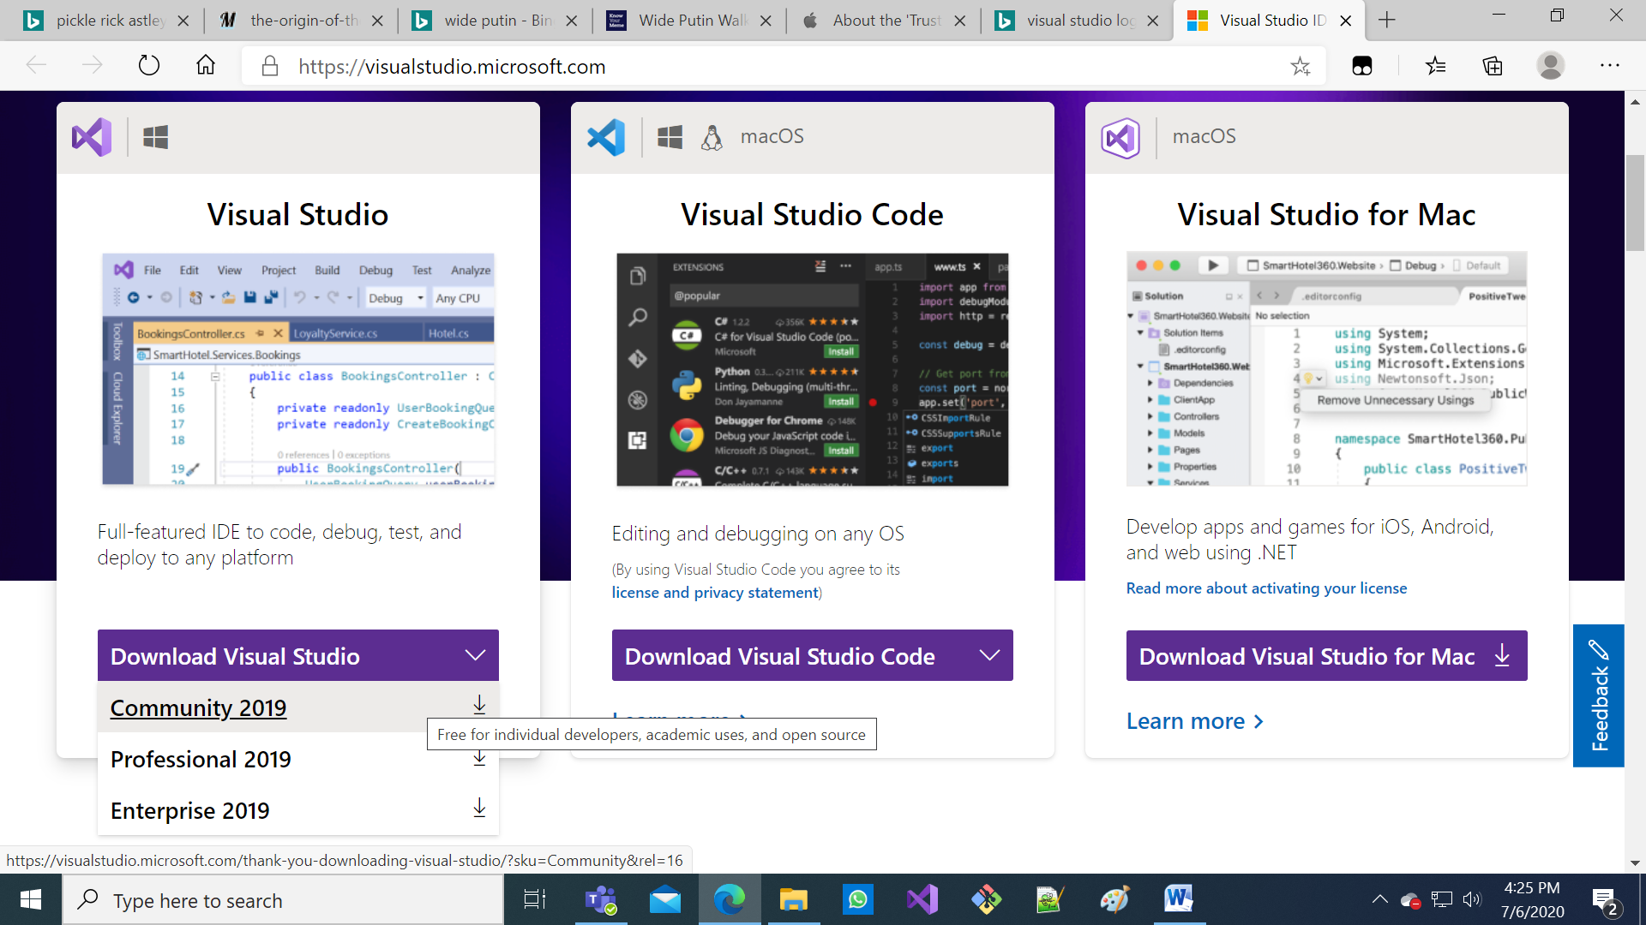
3. Select “Mobile development with .NET” in the installer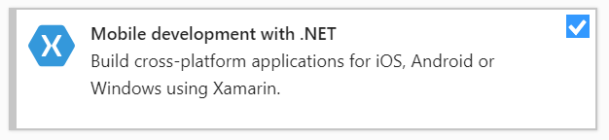
4. (For iOS users)
   * Install Xcode on your Mac via the App Store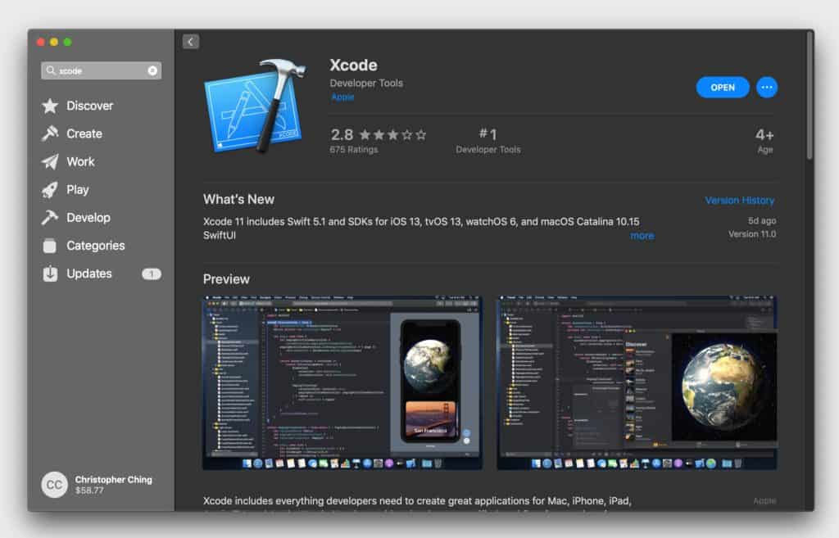

Downloading the template:

1. Hold the Windows key while pressing R which brings up the Run box 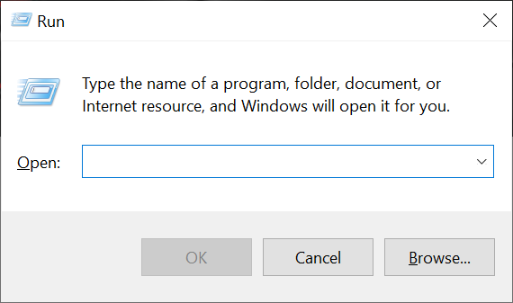
2. Paste cmd /k "cd %HOMEPATH% && dotnet new -i Fabulous.XamarinForms.Templates && dotnet new fabulous-xf-app --force -n PedoApp && start PedoApp/PedoApp.sln"  
    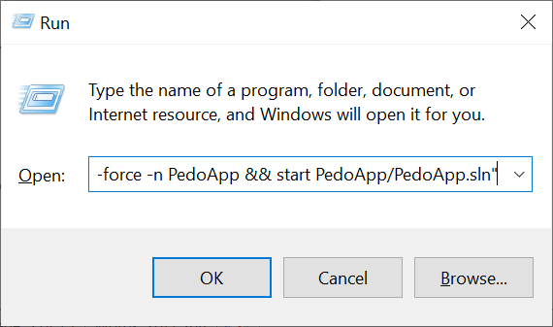
3. Press OK and wait

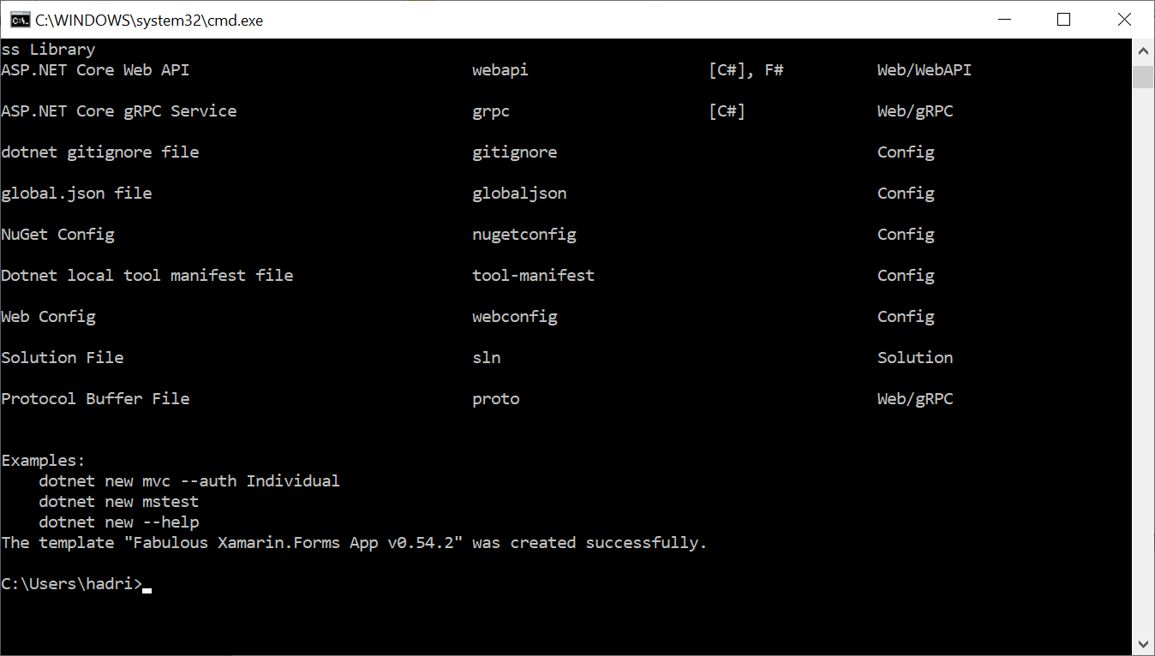

B. Starting a new project

1. Wait for Visual Studio to load
2. Open Solution Explorer 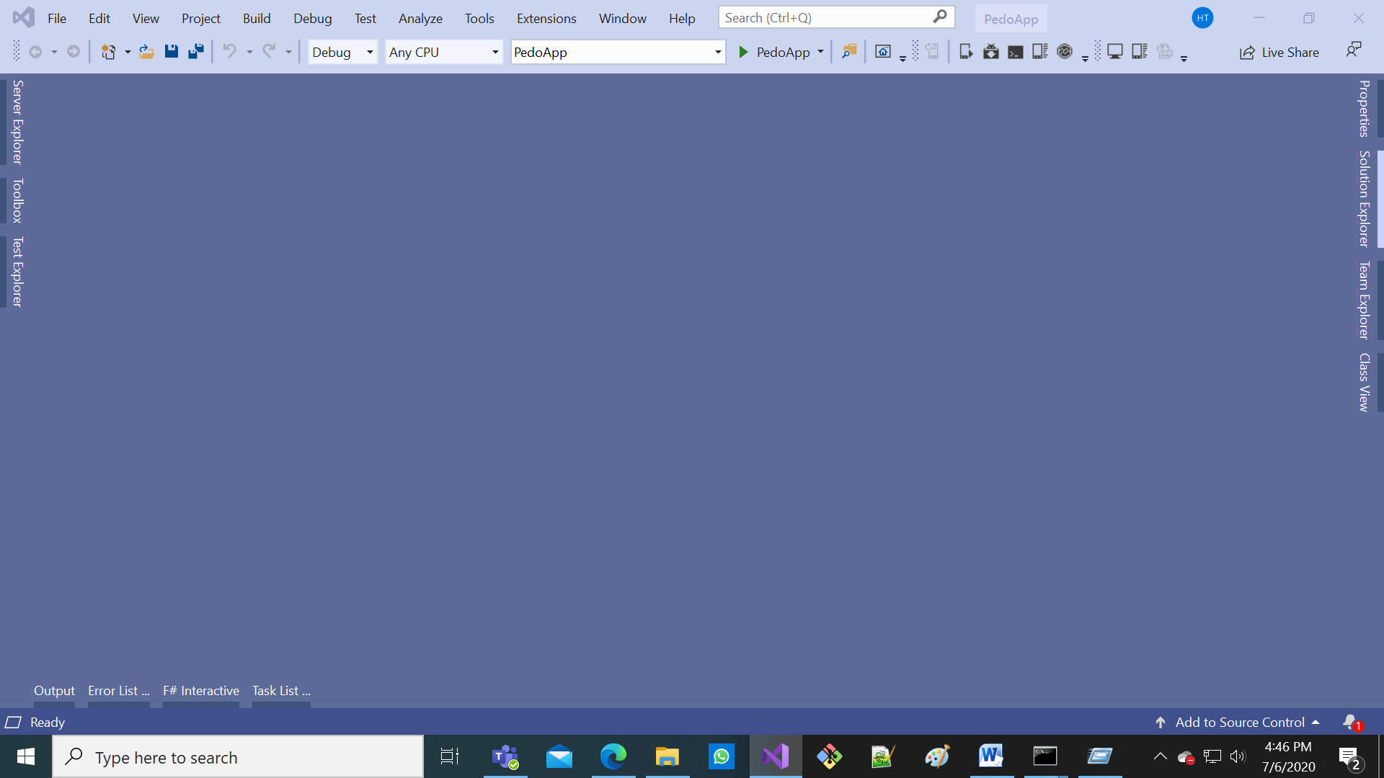
3. Press the black right-pointing triangle to the left of “PedoApp” 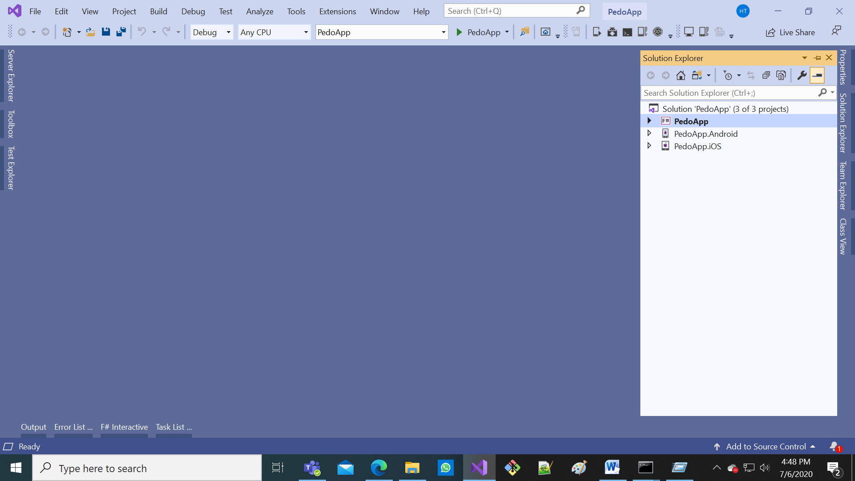
4. Select “PedoApp.fs” (remember this as “PedoApp.fs”)

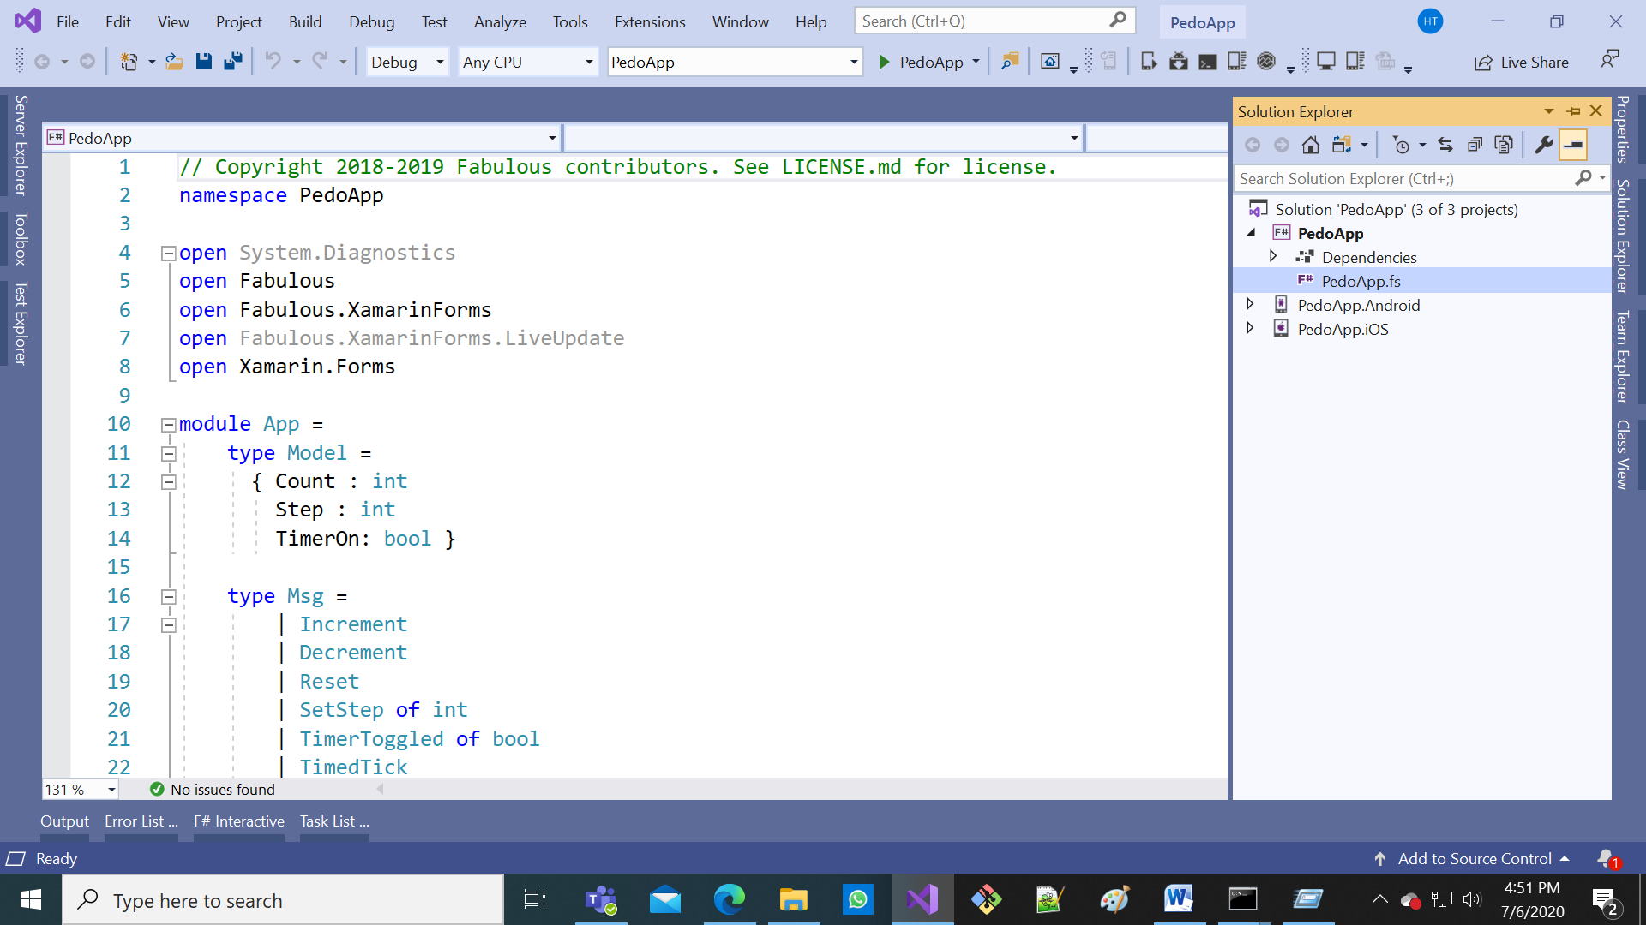

C. Structure of a program

// Copyright 2018-2019 Fabulous contributors. See LICENSE.md for license.

namespace PedoApp

We “open” to import code from other people

open System.Diagnostics

open Fabulous

open Fabulous.XamarinForms

open Fabulous.XamarinForms.LiveUpdate

open Xamarin.Forms

int: Integer (Whole number), e.g. -3, -2, -1, 0, 1, 2, 3…  
bool: Boolean (True/False) “3 = 3” “2.3 = 2.3” are True “3 = 4” “3 ≠ 3” are False

module App =

type Model =

{ Count : int

“Model” is the status of the app (nouns)

Count: Current number in counter

Step: Change in number every increment   
TimerOn: Whether number increments automatically

Step : int

TimerOn: bool }

type Msg =

| Increment

| Decrement

“Msg”, aka “Message”, is an event that can cause the “Model” to change (verbs)

| Reset

| SetStep of int

| TimerToggled of bool

| TimedTick

“initModel”, aka Initial Model, is the status of the app after launch

let initModel = { Count = 0; Step = 1; TimerOn=false }

let init () = initModel, Cmd.none

“init”: Combines “initModel” and a “Cmd” that represents additional “Msg”s after app launch

“Cmd”, aka “Command”, decide whether additional “Msg”s are sent after a “Msg” is handled

Cmd.none: We don’t cause additional “Msg”s after app launch

let timerCmd =

async { do! Async.Sleep 200

return TimedTick }

|> Cmd.ofAsyncMsg

timerCmd: A “Cmd” that cause TimedTick (a “Msg”) after 200 milliseconds

“update”: How each “Msg” changes “Model” and optionally causes more “Msg”s through “Cmd”s

let update msg model =

match msg with

| Increment -> { model with Count = model.Count + model.Step }, Cmd.none

| Decrement -> { model with Count = model.Count – model.Step }, Cmd.none

| Reset -> init ()

| SetStep n -> { model with Step = n }, Cmd.none

| TimerToggled on -> { model with TimerOn = on }, (if on then timerCmd else Cmd.none)

| TimedTick ->

if model.TimerOn then

{ model with Count = model.Count + model.Step }, timerCmd

else

“view”: Convert “Model” to an actual User Interface

model, Cmd.none

let view (model: Model) dispatch =

View.ContentPage(

content = View.StackLayout(padding = Thickness 20.0, verticalOptions = LayoutOptions.Center,

children = [

View.Label(text = print “%d” model.Count, horizontalOptions = LayoutOptions.Center, width=200.0, horizontalTextAlignment=TextAlignment.Center)

View.Button(text = “Increment”, command = (fun () -> dispatch Increment), horizontalOptions = LayoutOptions.Center)

View.Button(text = “Decrement”, command = (fun () -> dispatch Decrement), horizontalOptions = LayoutOptions.Center)

View.Label(text = “Timer”, horizontalOptions = LayoutOptions.Center)

View.Switch(isToggled = model.TimerOn, toggled = (fun on -> dispatch (TimerToggled on.Value)), horizontalOptions = LayoutOptions.Center)

View.Slider(minimumMaximum = (0.0, 10.0), value = double model.Step, valueChanged = (fun args -> dispatch (SetStep (int (args.NewValue + 0.5)))), horizontalOptions = LayoutOptions.FillAndExpand)

View.Label(text = print “Step size: %d” model.Step, horizontalOptions = LayoutOptions.Center)

View.Button(text = “Reset”, horizontalOptions = LayoutOptions.Center, command = (fun () -> dispatch Reset), commandCanExecute = (model <> initModel))

]))

// Note, this declaration is needed if you enable LiveUpdate

let program = XamarinFormsProgram.mkProgram init update view

“program”: Combine “init”, “update” and “view” into an app

type App () as app =

inherit Application ()

let runner =

App.program

#if DEBUG

Run the “program” on app launch

|> Program.withConsoleTrace

#endif

|> XamarinFormsProgram.run app

#if DEBUG

// Uncomment this line to enable live update in debug mode.

// See https://fsprojects.github.io/Fabulous/Fabulous.XamarinForms/tools.html#live-update for further instructions.

//

Live Update: We don’t need it right now

//do runner.EnableLiveUpdate()

#endif

// Uncomment this code to save the application state to app.Properties using Newtonsoft.Json

// See https://fsprojects.github.io/Fabulous/Fabulous.XamarinForms/models.html#saving-application-state for further instructions.

#if APPSAVE

Reusing “Model” from previous launches: We don’t need it right now

let modelId = “model”

override __.OnSleep() =

let json = Newtonsoft.Json.JsonConvert.SerializeObject(runner.CurrentModel)

Console.WriteLine(“OnSleep: saving model into app.Properties, json = {0}”, json)

app.Properties.[modelId] <- json

override __.OnResume() =

Console.WriteLine “OnResume: checking for model in app.Properties”

try

match app.Properties.TryGetValue modelId with

| true, (:? String as json) ->

Console.WriteLine(“OnResume: restoring model from app.Properties, json = {0}”, json)

let model = Newtonsoft.Json.JsonConvert.DeserializeObject<App.Model>(json)

Console.WriteLine(“OnResume: restoring model from app.Properties, model = {0}”, (print “%0A” model))

runner.SetCurrentModel (model, Cmd.none)

| _ -> ()

with ex ->

App.program.onError(“Error while restoring model found in app.Properties”, ex)

override this.OnStart() =

Console.WriteLine “OnStart: using same logic as OnResume()”

this.OnResume()

#endif

D. Run the app (Android)

1. Enable USB Debugging in your phone   
   (NOTE: the Settings UI is different for each brand, below UI is for stock Android)
   * Go to Settings > About phone > Hit Build number for 7 times until get a message “You are now a developer!”
   * Back to Settings > Developer options > USB debugging > Tap OK.

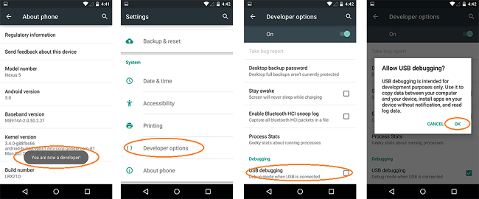

1. Plug your phone into the computer via a USB cable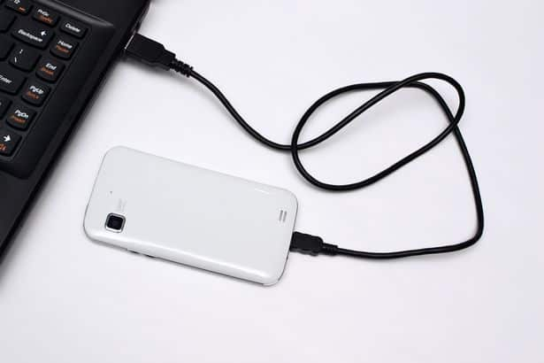
2. Select “PedoApp.Android” as the startup project via the Startup Projects dropdown at the top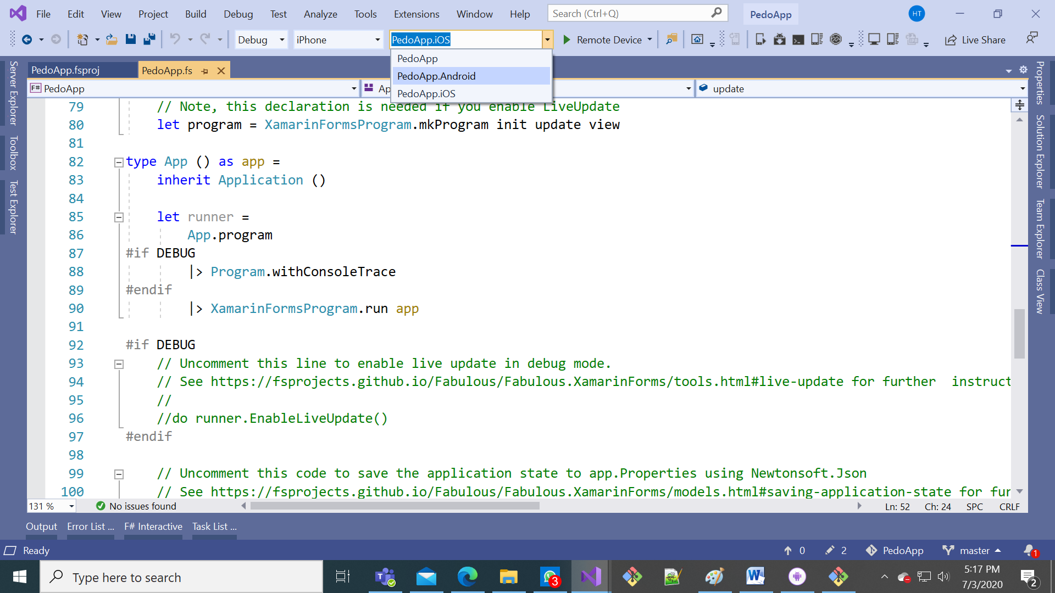

1

2

1

1. Select your device from the Target Device dropdown menu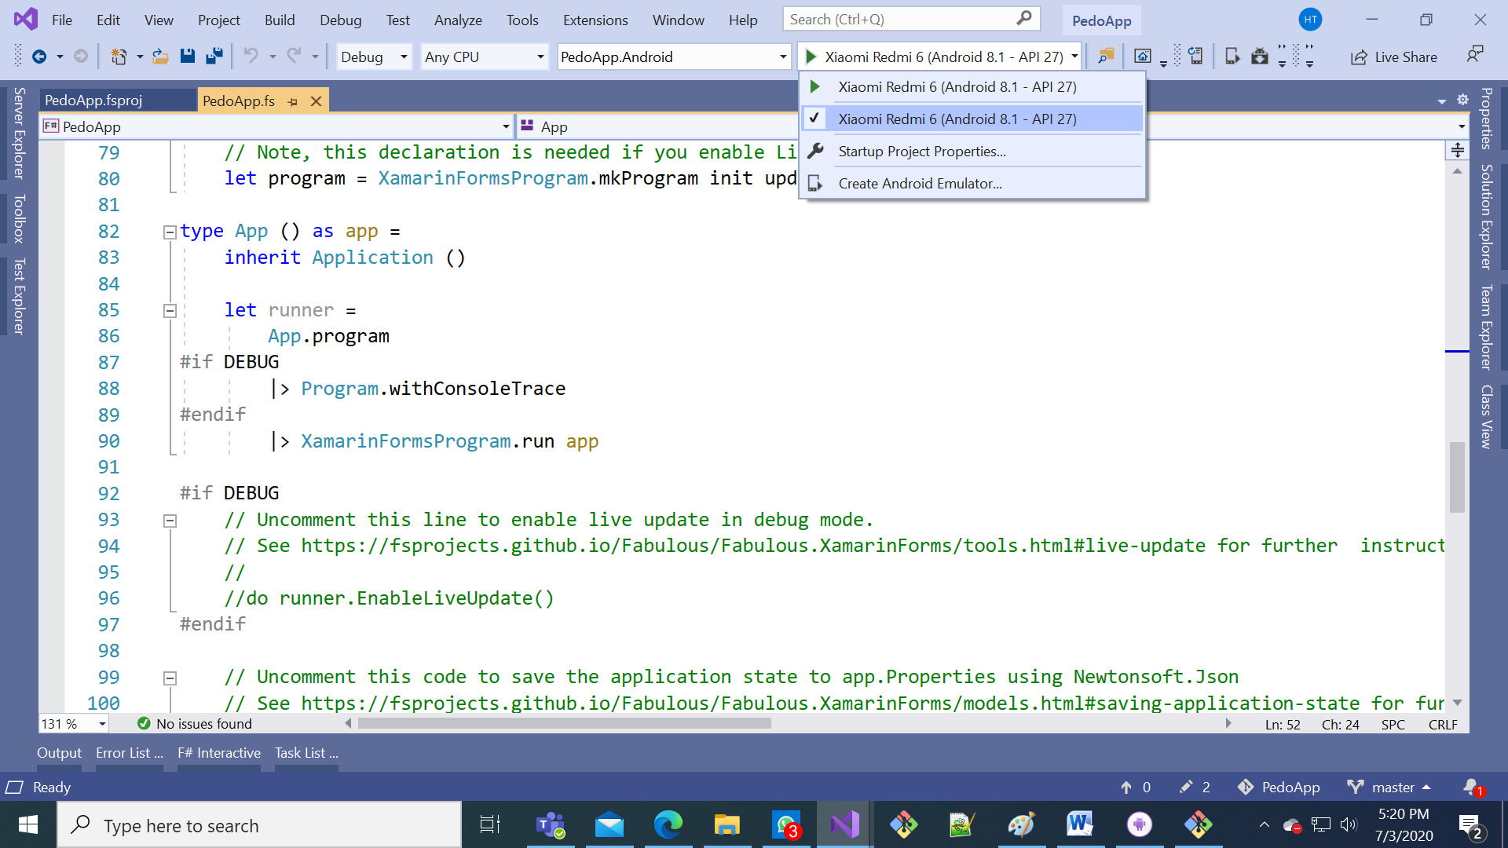

2

1. Press the green arrow to start debugging 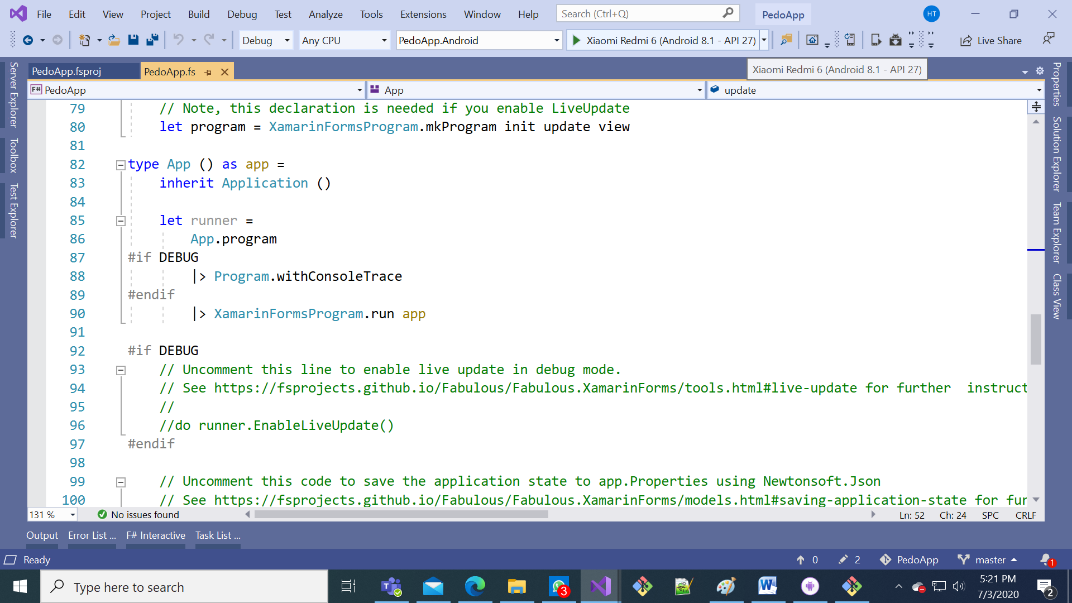
2. Watch out for installation dialogs on your phone and accept all the dialogs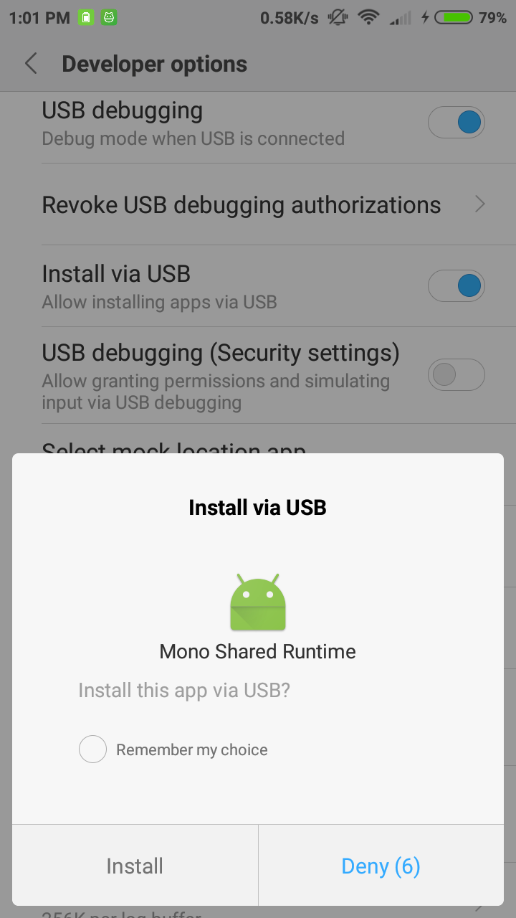
3. The app should launch by itself on your phone

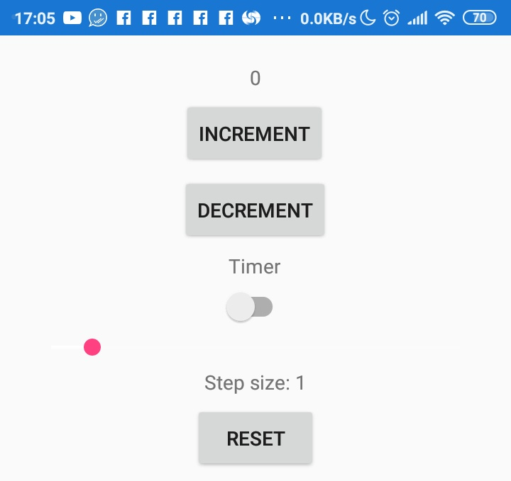

E. Connecting the Windows computer to the Mac (required for iOS) - needs to be done per run of Visual Studio

1. Make sure that the Mac and the Windows computer are on the same network

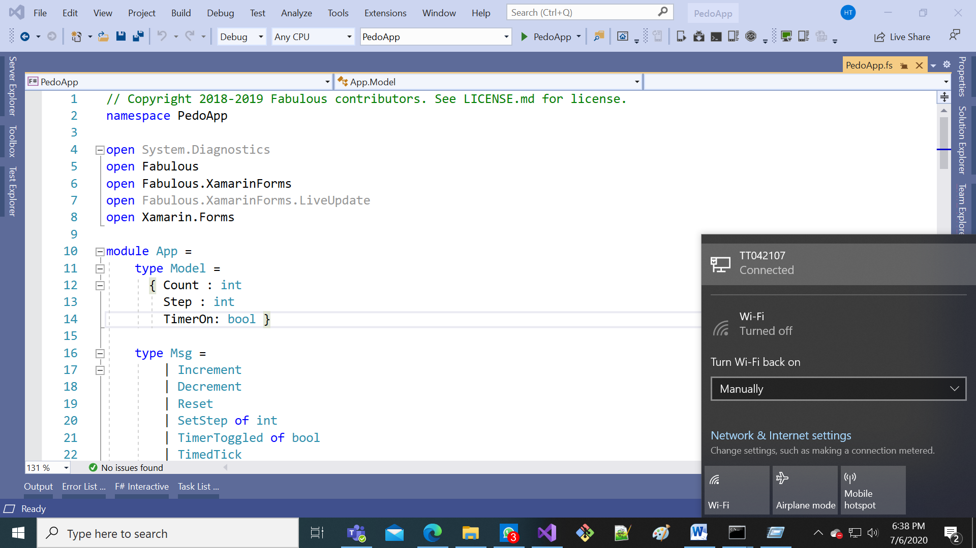

4

3

1

2

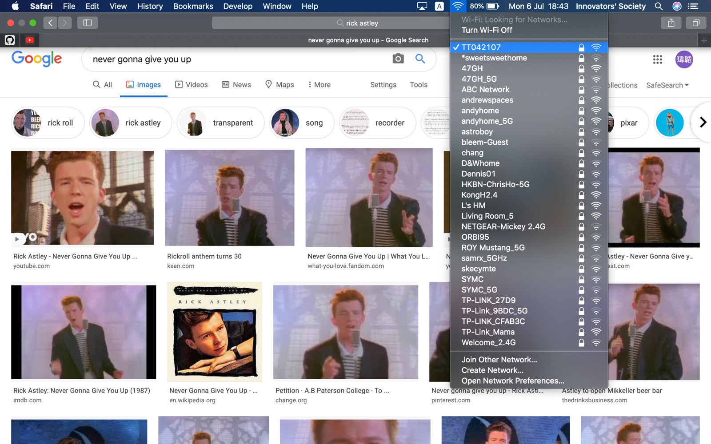

1. On the Mac, open System Preferences under the Apple menu

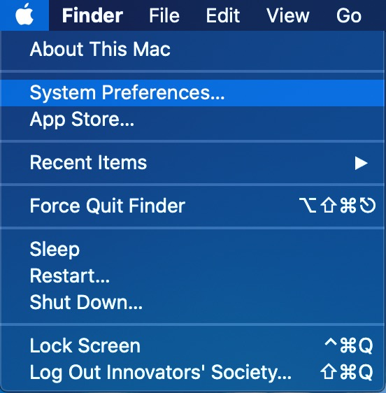

1. Search “Remote Login” and press the result

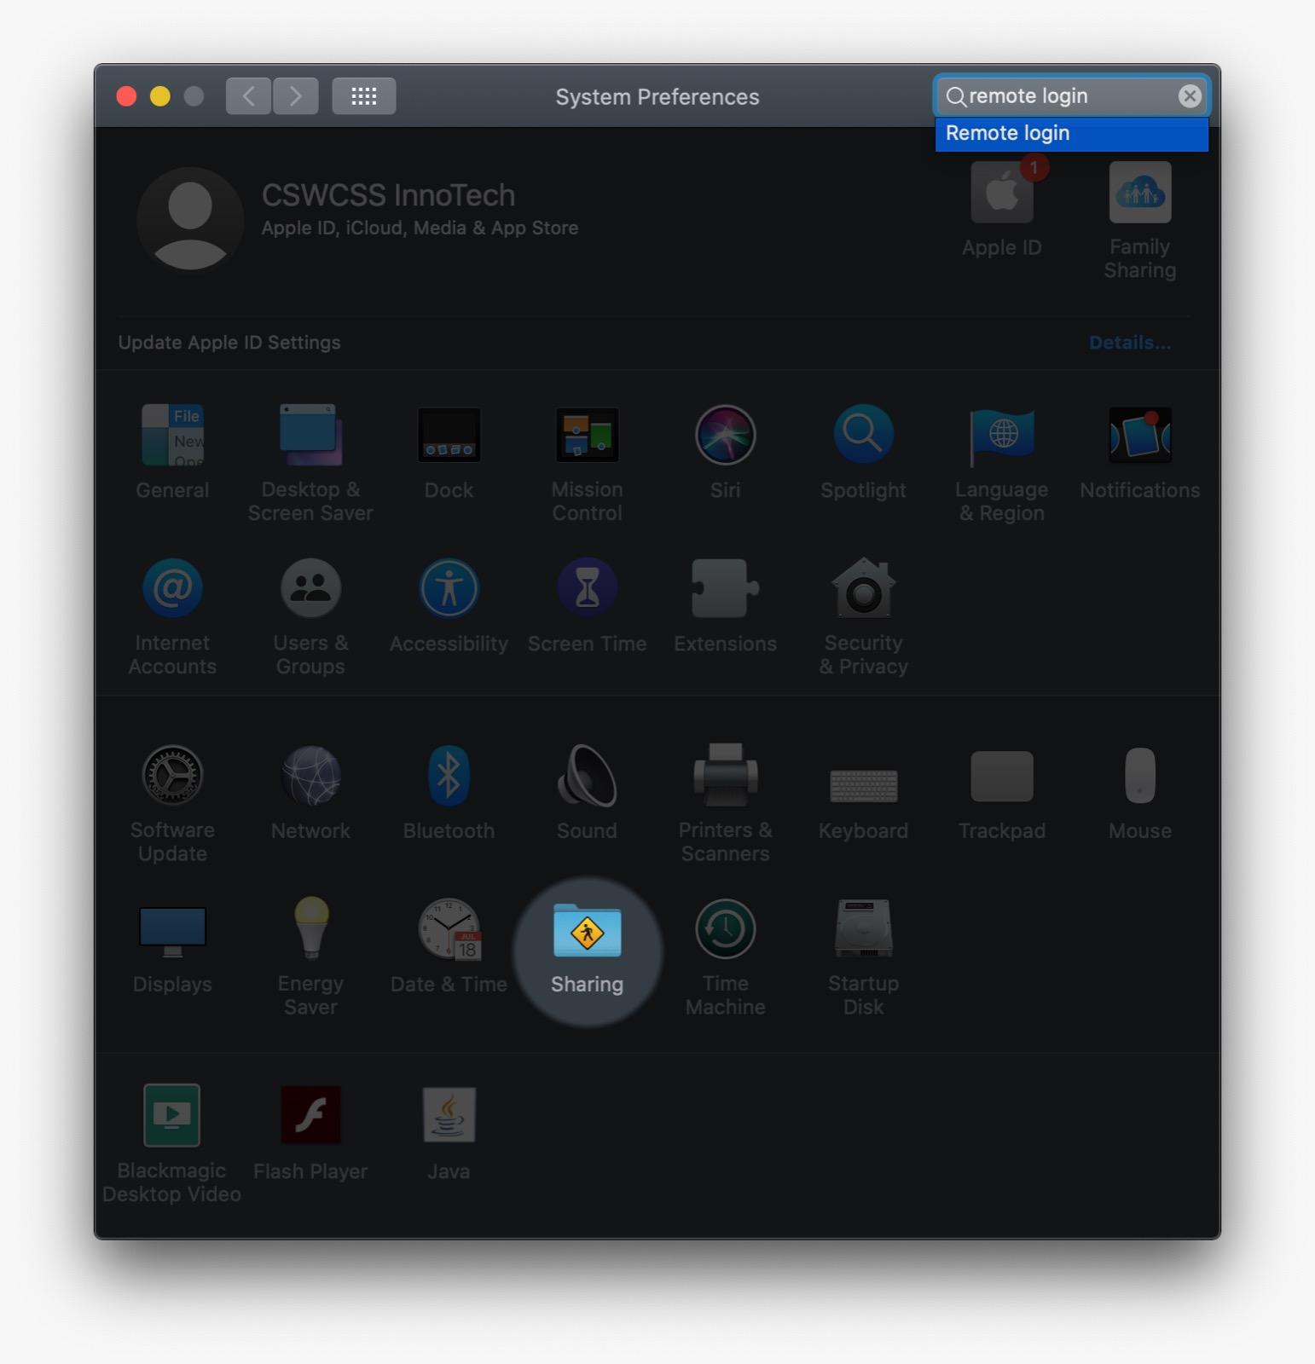

1. Enable Remote Login and remember the Username and IP Address

Username

IP Address

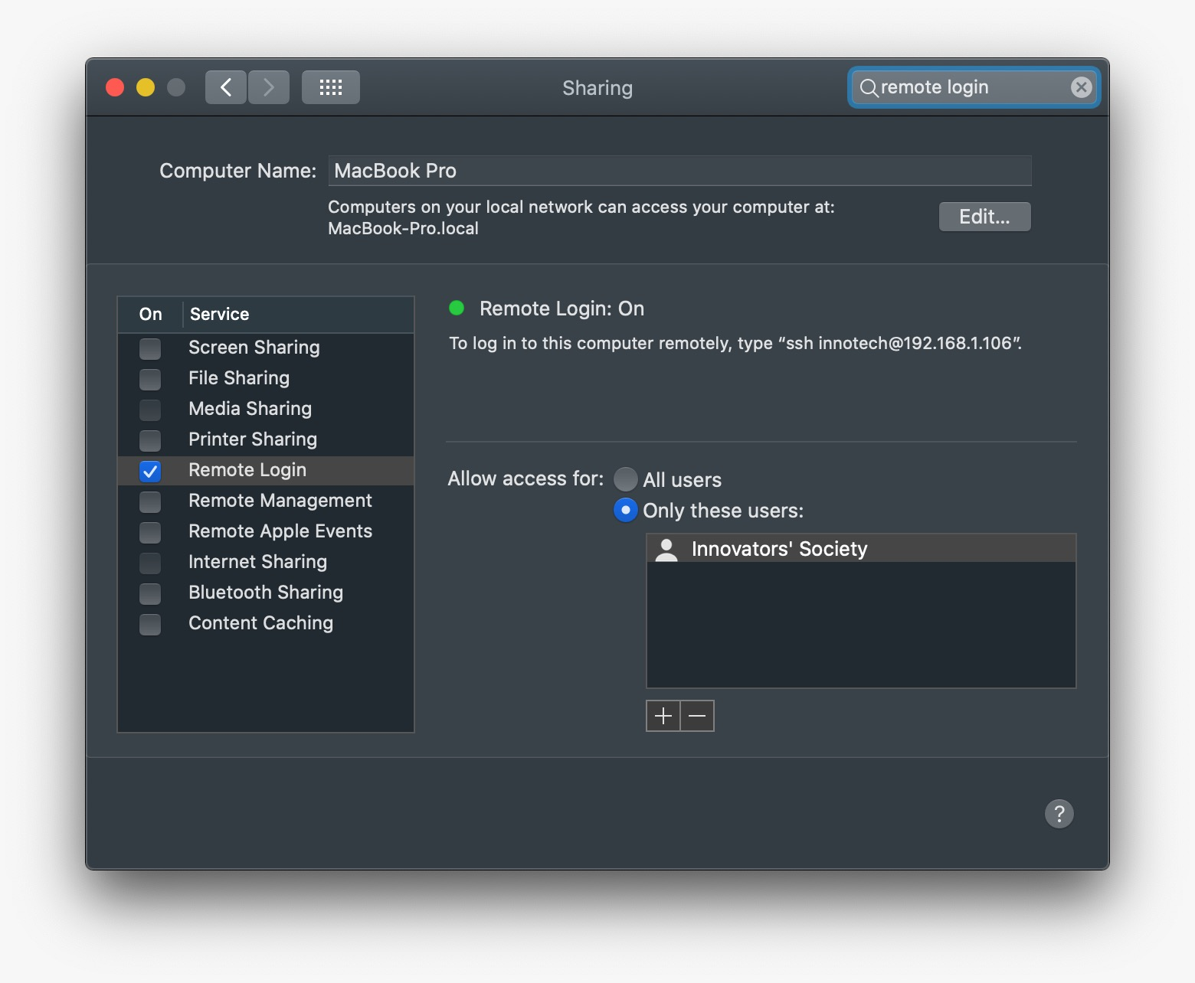

1. Back to the Windows computer, open Tools > iOS > Pair to Mac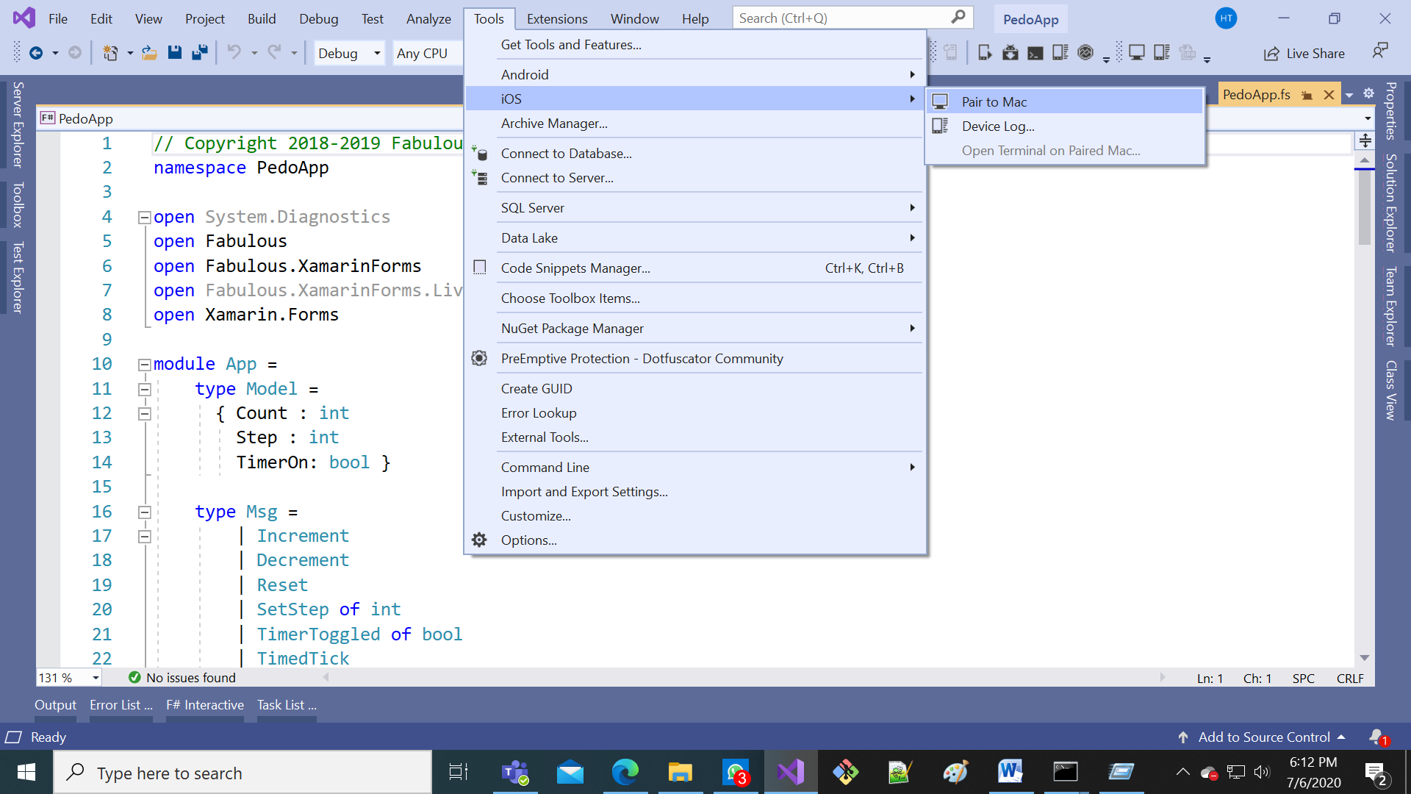
2. Select the Mac with matching IP Address from above from above then press “Connect…”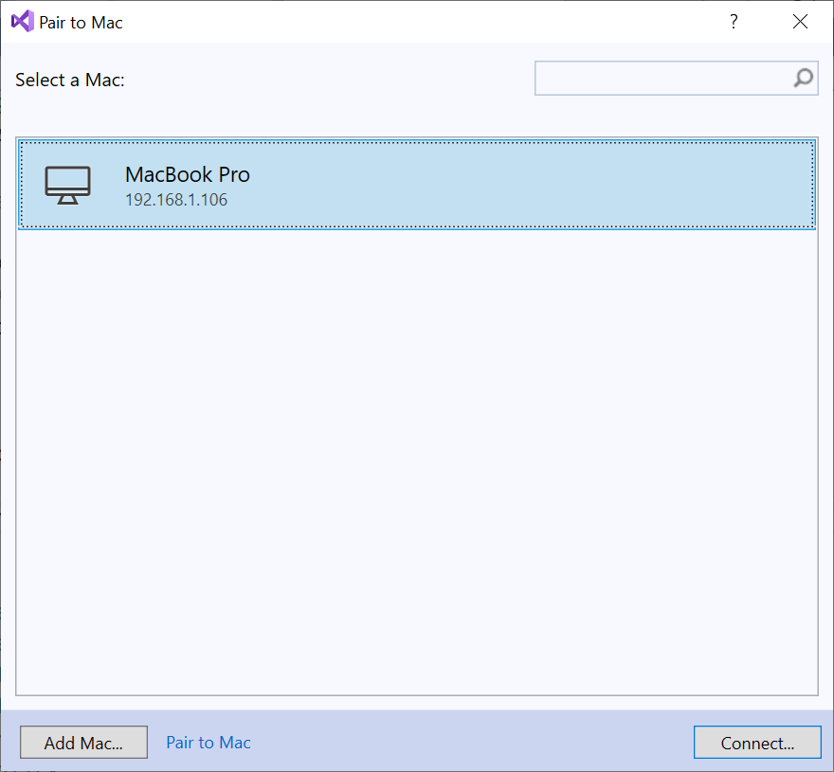
   * If no Macs show up, then press “Add Mac…” to the bottom-left
   * Enter the IP Address from above then press Add  
     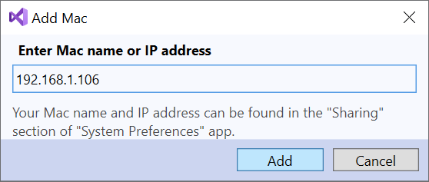
3. If required, enter the Username from above and the login password for that Mac user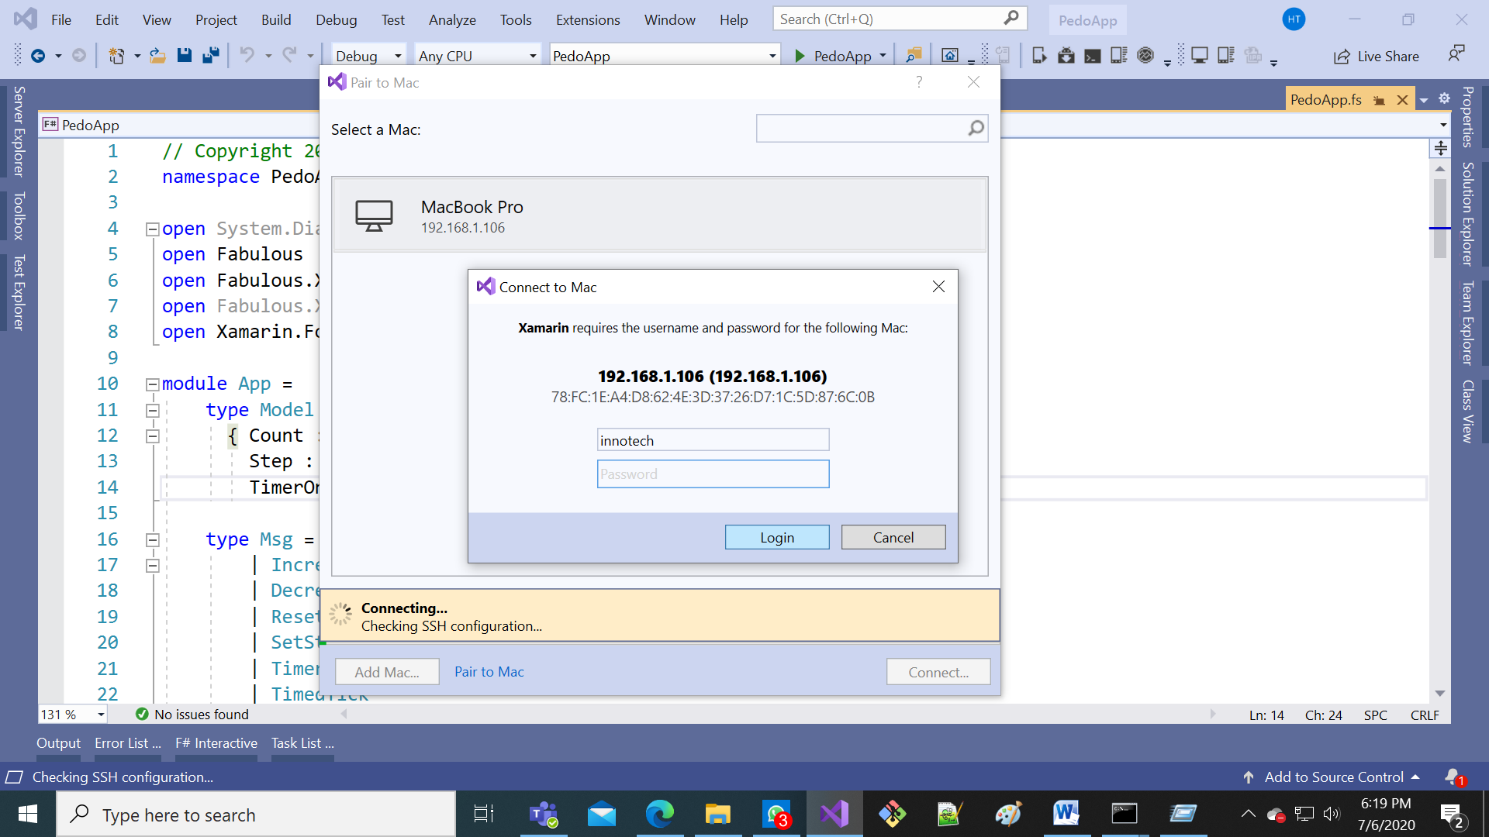
4. If prompted to install Mono and Xamarin.iOS, press Install  
   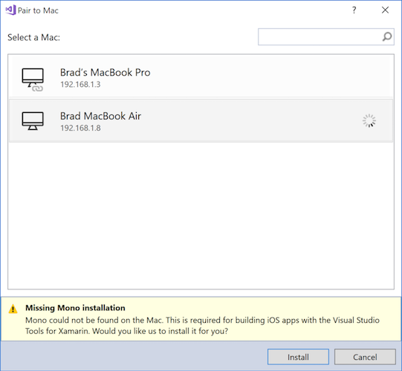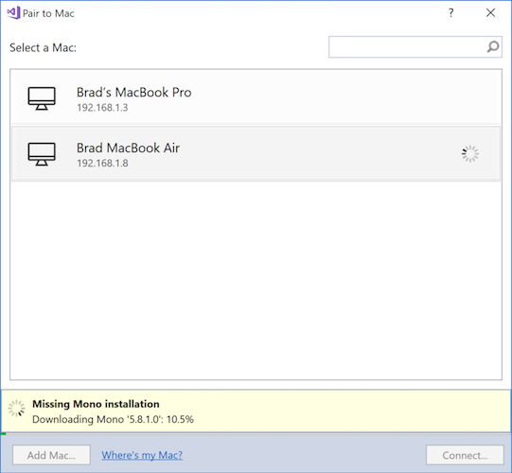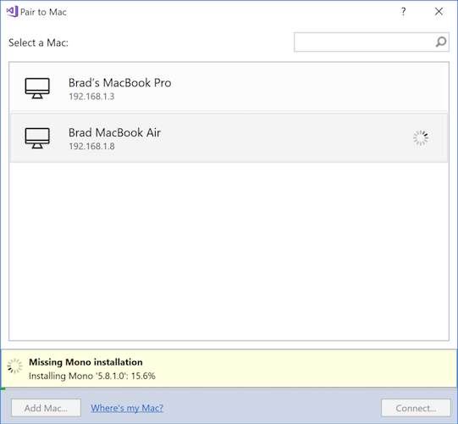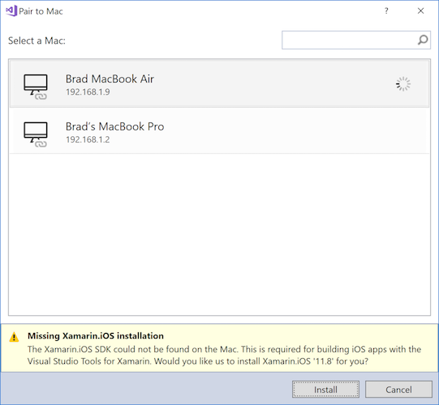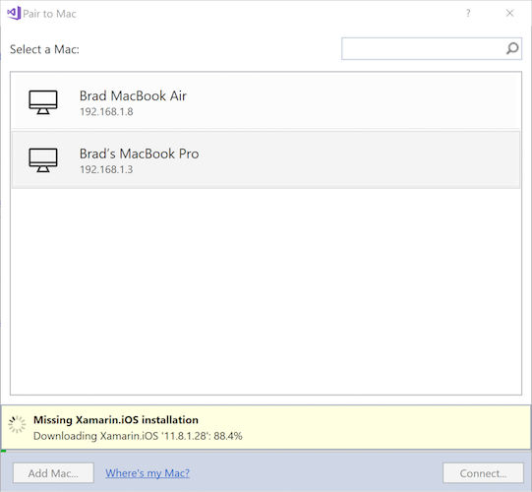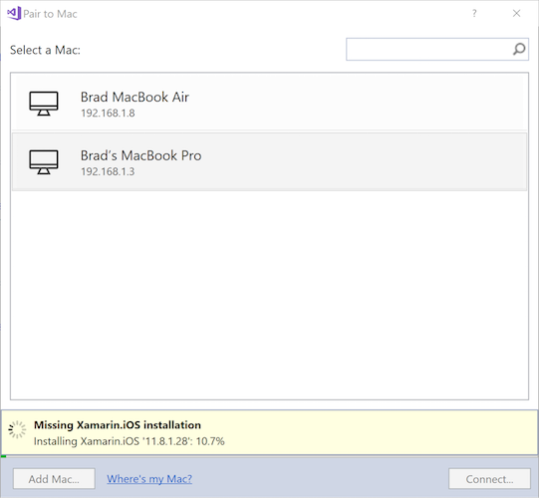
5. If prompted, accept the Xcode license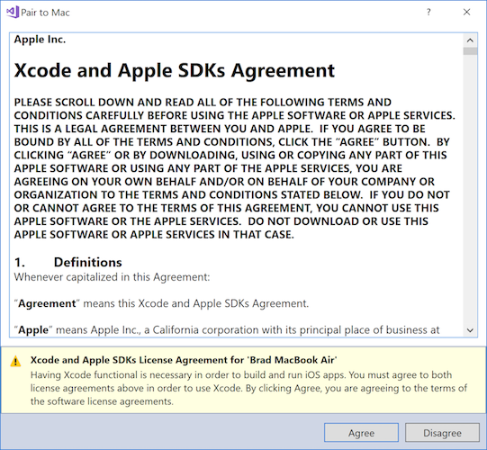
6. Wait until successful connection indicated by connection symbols  
   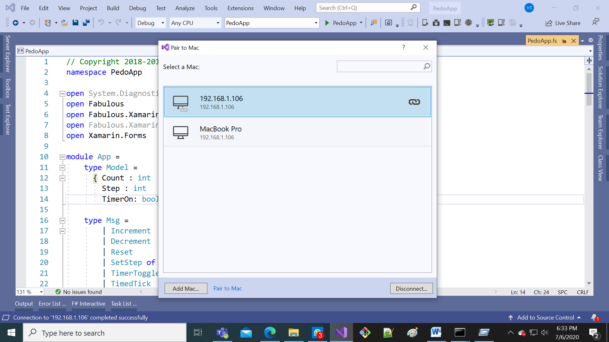

F. Free provisioning (required for iOS) – needs to be done once per device-app combination

Free provisioning allows developers to deploy and test their apps on iOS devices without being part of the Apple Developer Program. However, Apple has imposed a number of limitations on when and how you can use free provisioning to run your application on an iOS device, ensuring that you can only deploy to your device:

Access to iTunes Connect is limited and therefore services such as publishing to the App Store and TestFlight are unavailable to developers provisioning their applications freely. An Apple Developer Account (Enterprise or Personal), which costs USD$99 per year, is required to distribute via Ad Hoc and In-House means.

Provisioning profiles created with free provisioning will expire after one week, and signing identities will expire after one year.

Since Xcode will only create provisioning profiles for explicit App IDs, you will need to follow the instructions above for every app that you wish to install.

Provisioning for most application services is not possible with free provisioning. This includes Apple Pay, Game Center, iCloud, In-App Purchasing, Push Notifications, and Wallet. Apple provides a full list of capabilities in the Supported capabilities (iOS) guide. To provision your app for use with application services, visit the Working with capabilities guides.

1. Create an Apple ID if you have not already: <https://appleid.apple.com/>
2. On the Mac, open Xcode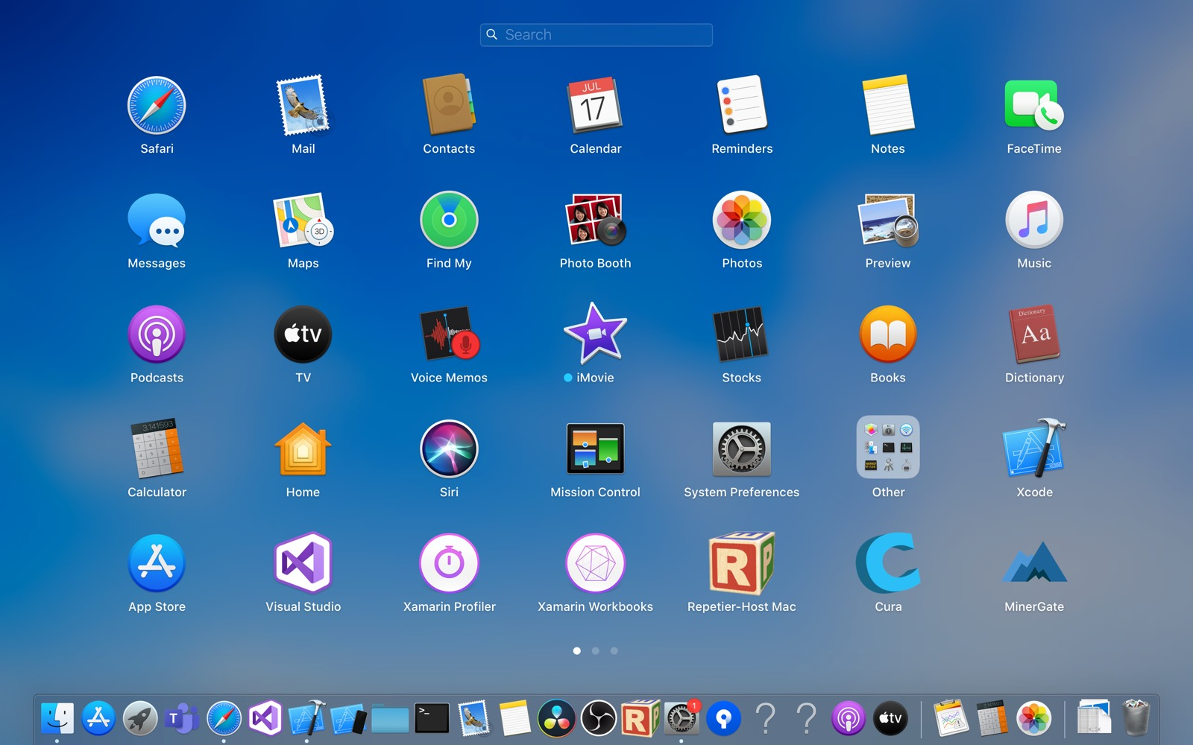
3. Open Xcode > Preferences

2

1

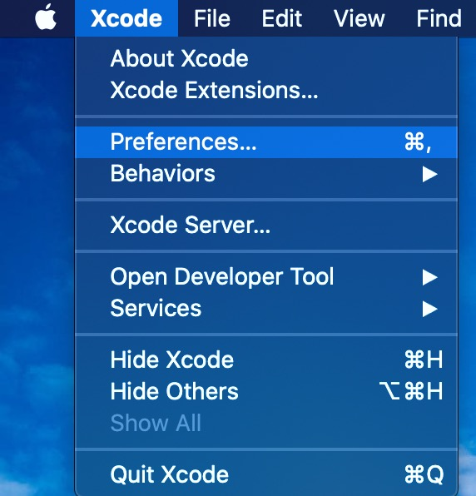

1. Under Accounts, use the + button to add your existing Apple ID

4

3

2

1

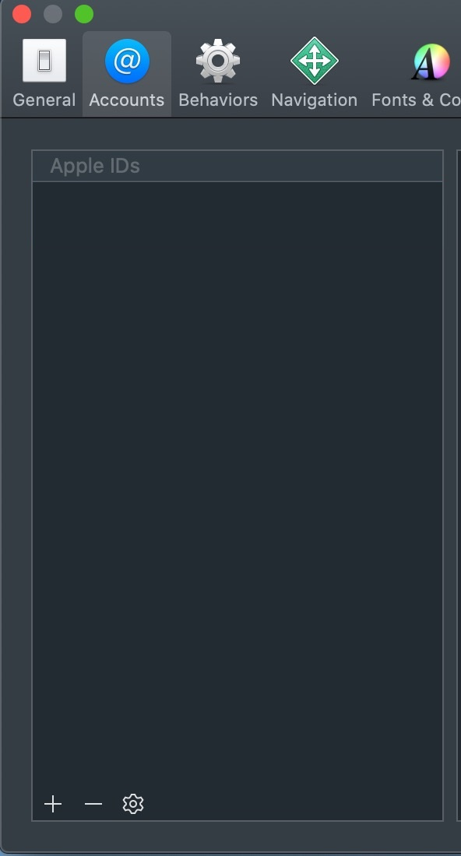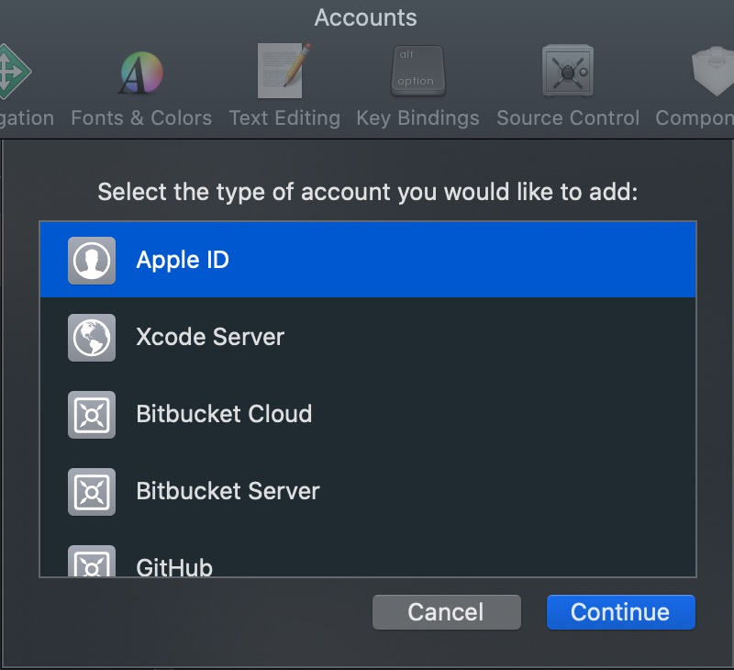

1. Enter the two-factor verification code if asked
2. Check that the Apple ID has been successfully added like below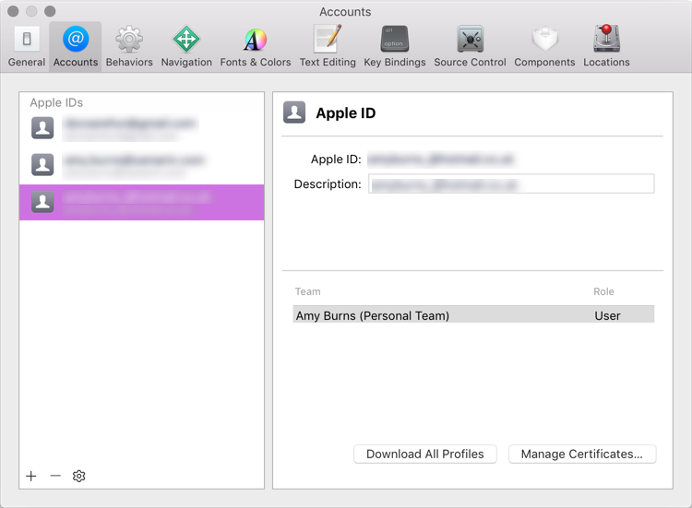
3. Close Xcode preferences
4. Plug the iPhone/iPad/iPod Touch into the Mac via a cable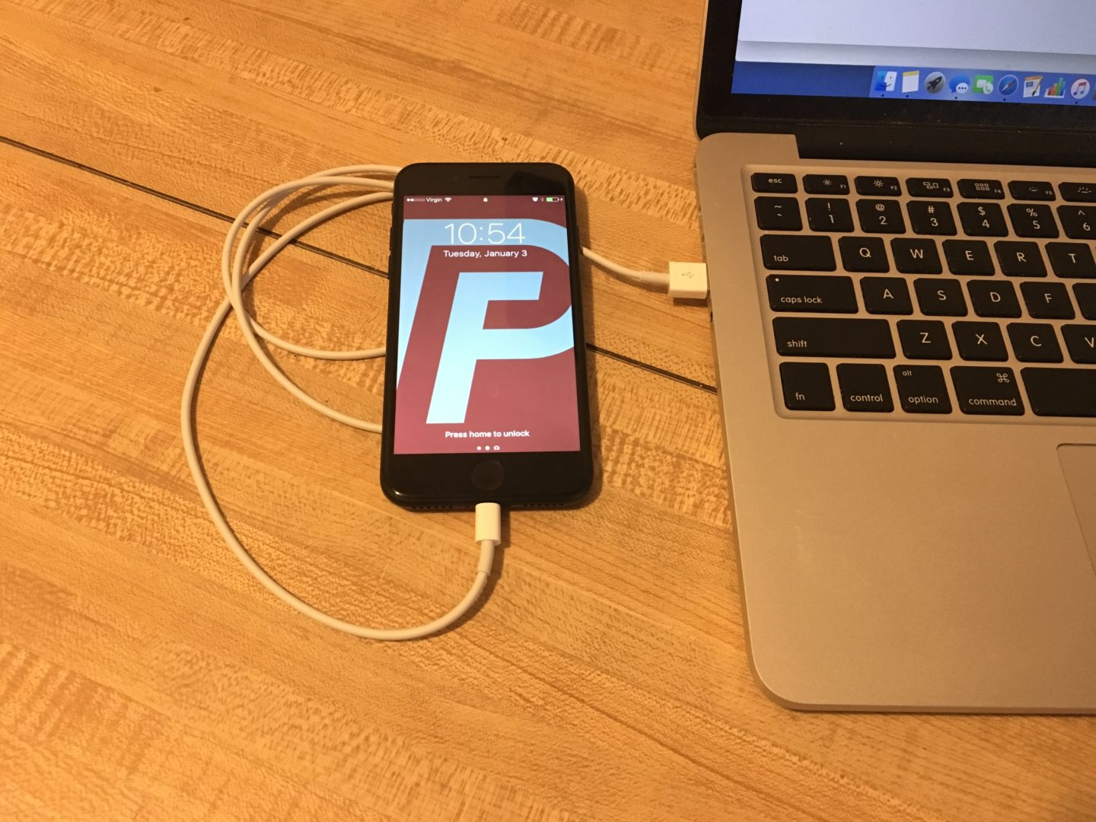
5. Accept the “Trust this computer” dialog on the iPhone/iPad/iPod Touch  
   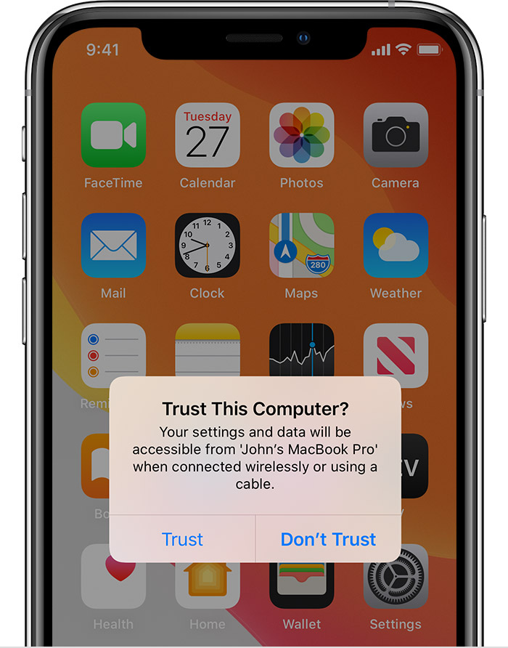
6. In Xcode, choose File > New > Project

1

3

2

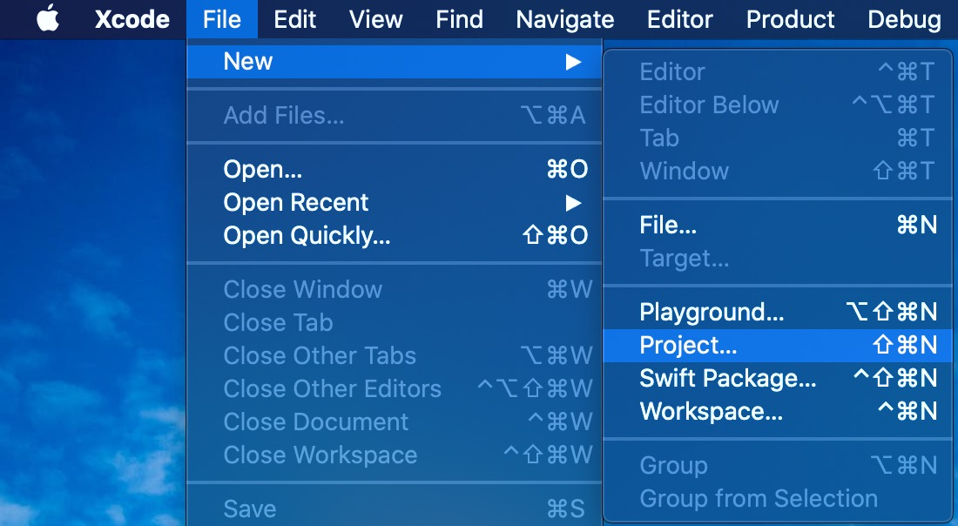

1. Select iOS > Single View App then Next

3

2

1

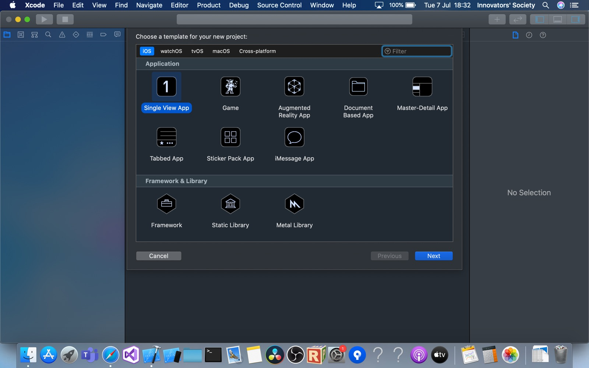

1. In the new project dialog, write “MyNewApp” to Product Name, then set Team to the Apple ID that you just added. In the drop-down list, it should look similar to “Your Name (Personal Team)”. Finally, click Next.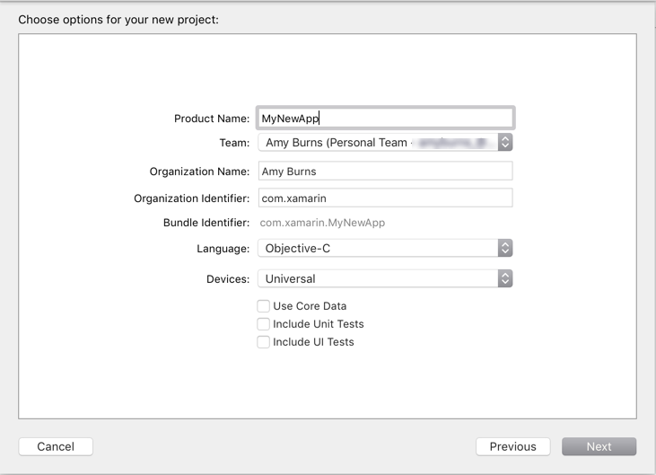

2

3

1

1. Click Create

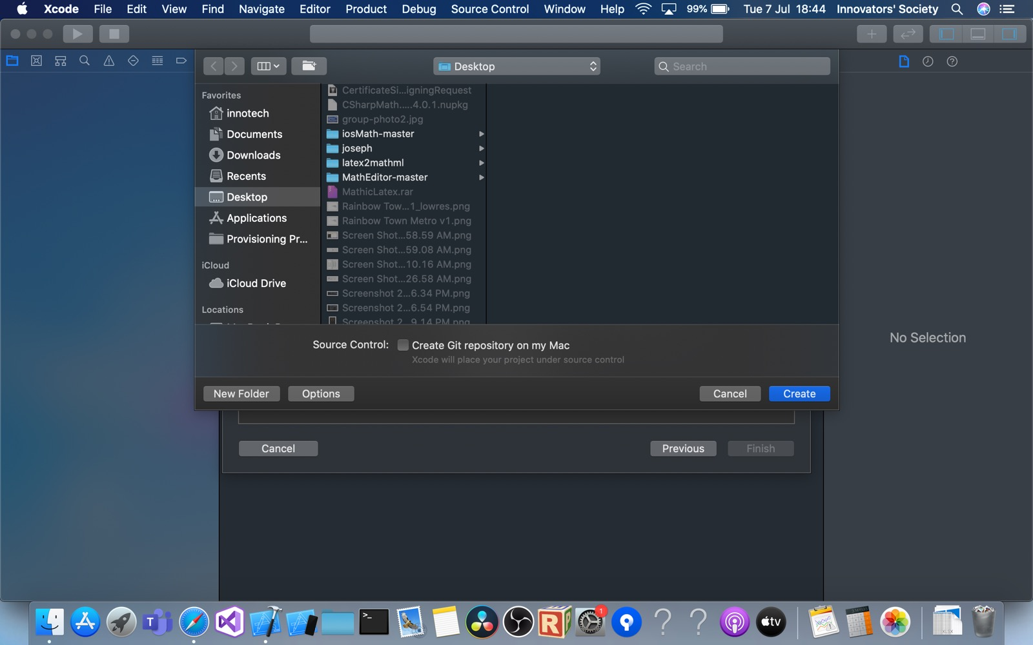

1. If the project already exists, replace it

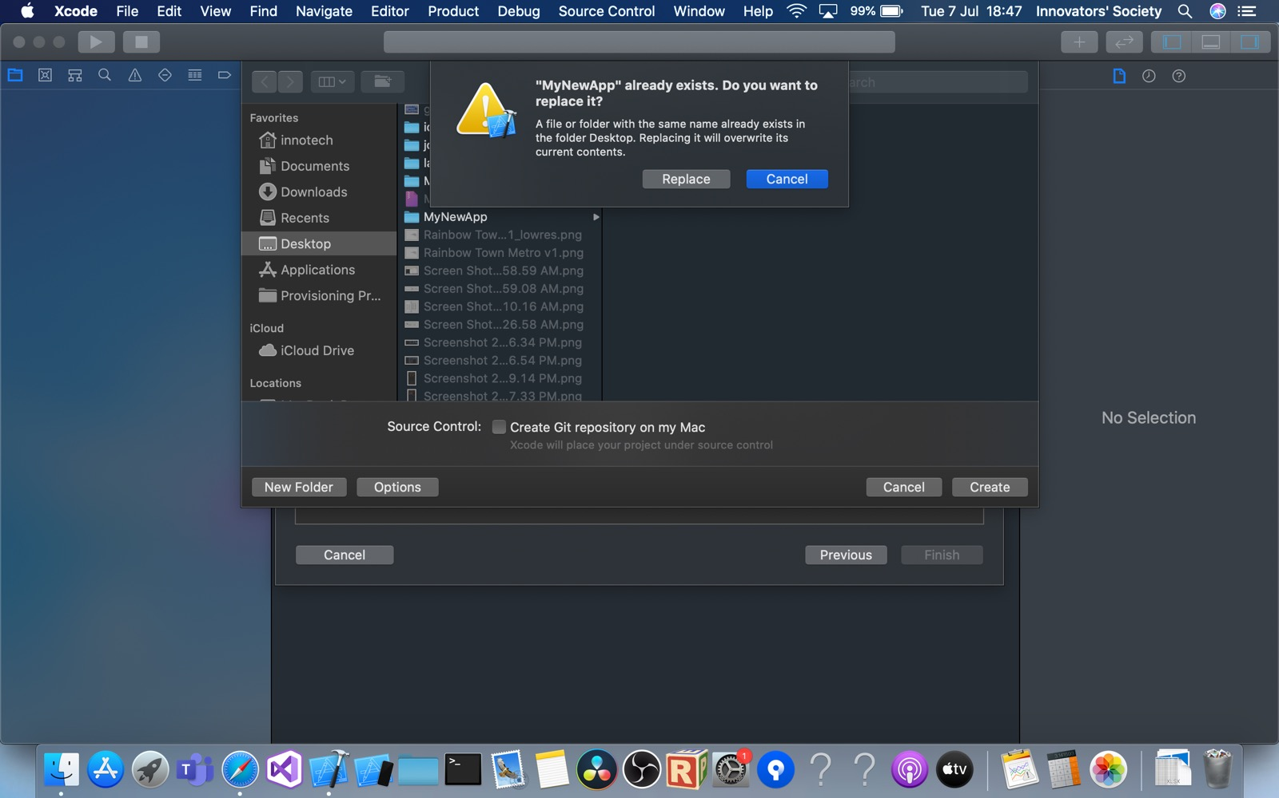

1. Click the build scheme destination dropdown

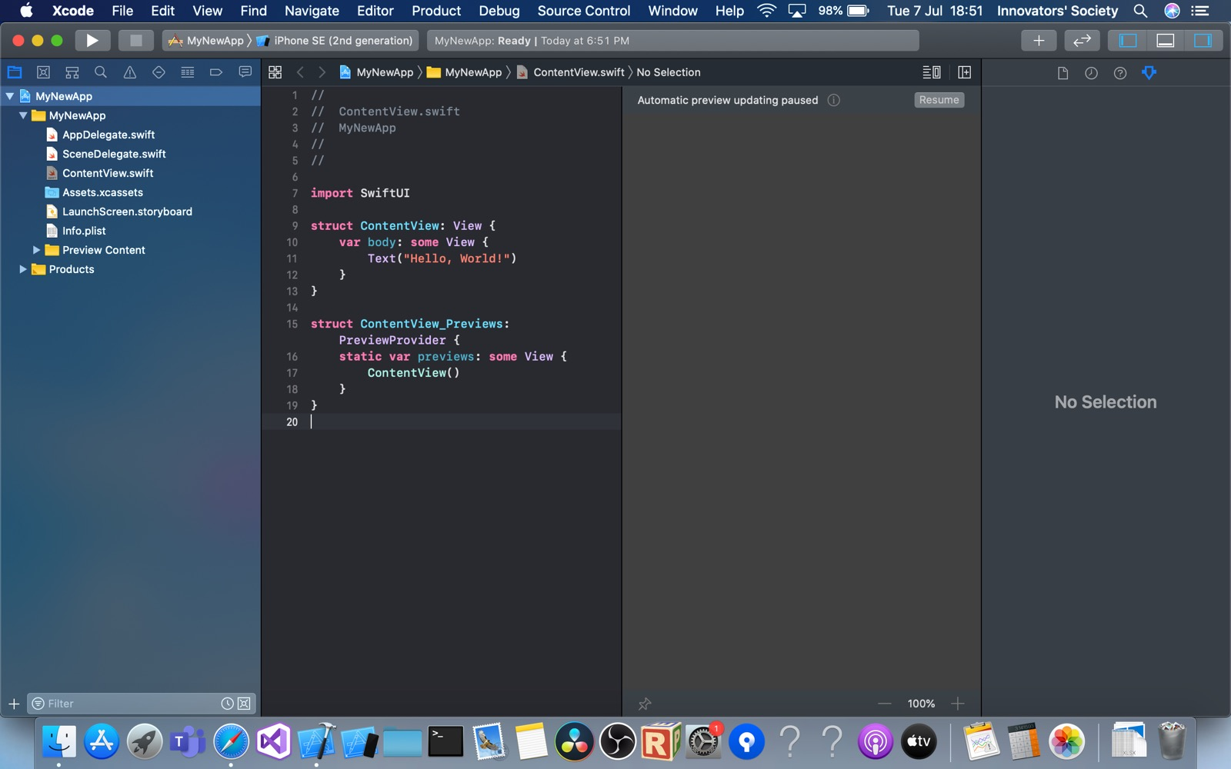

1. Select your device under Devices

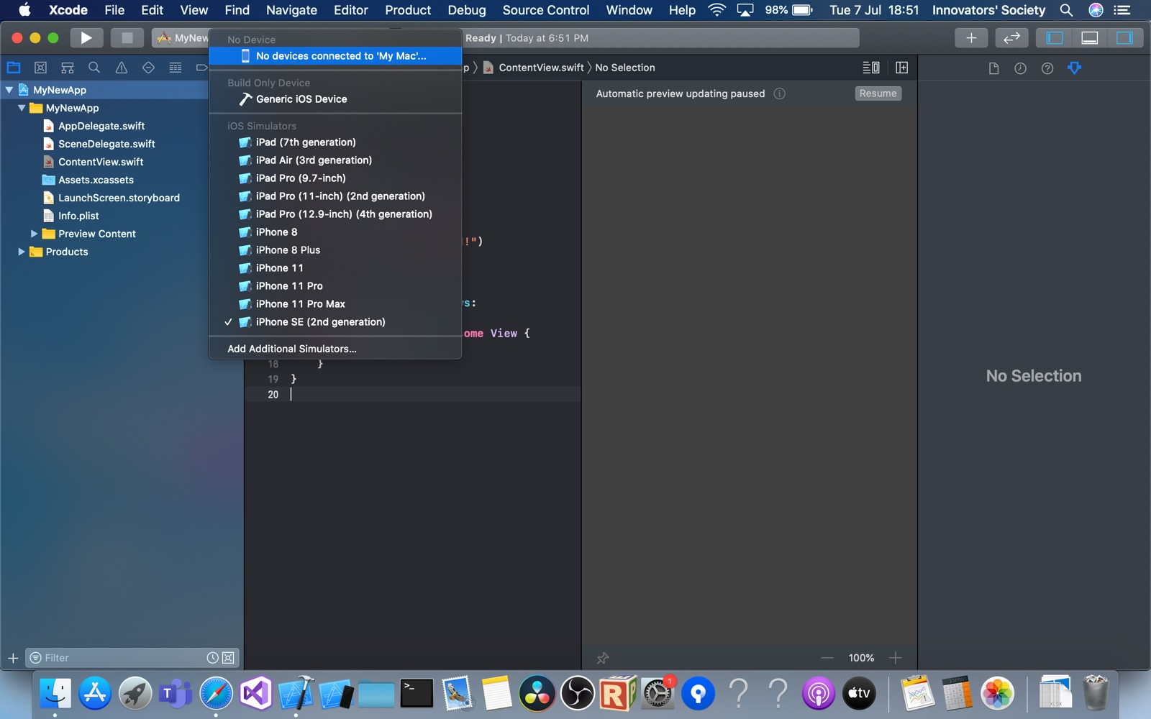

1. On the Windows computer, in Visual Studio, open Solution Explorer, under PedoApp.iOS, open Info.plist and remember the Bundle Identifier under Application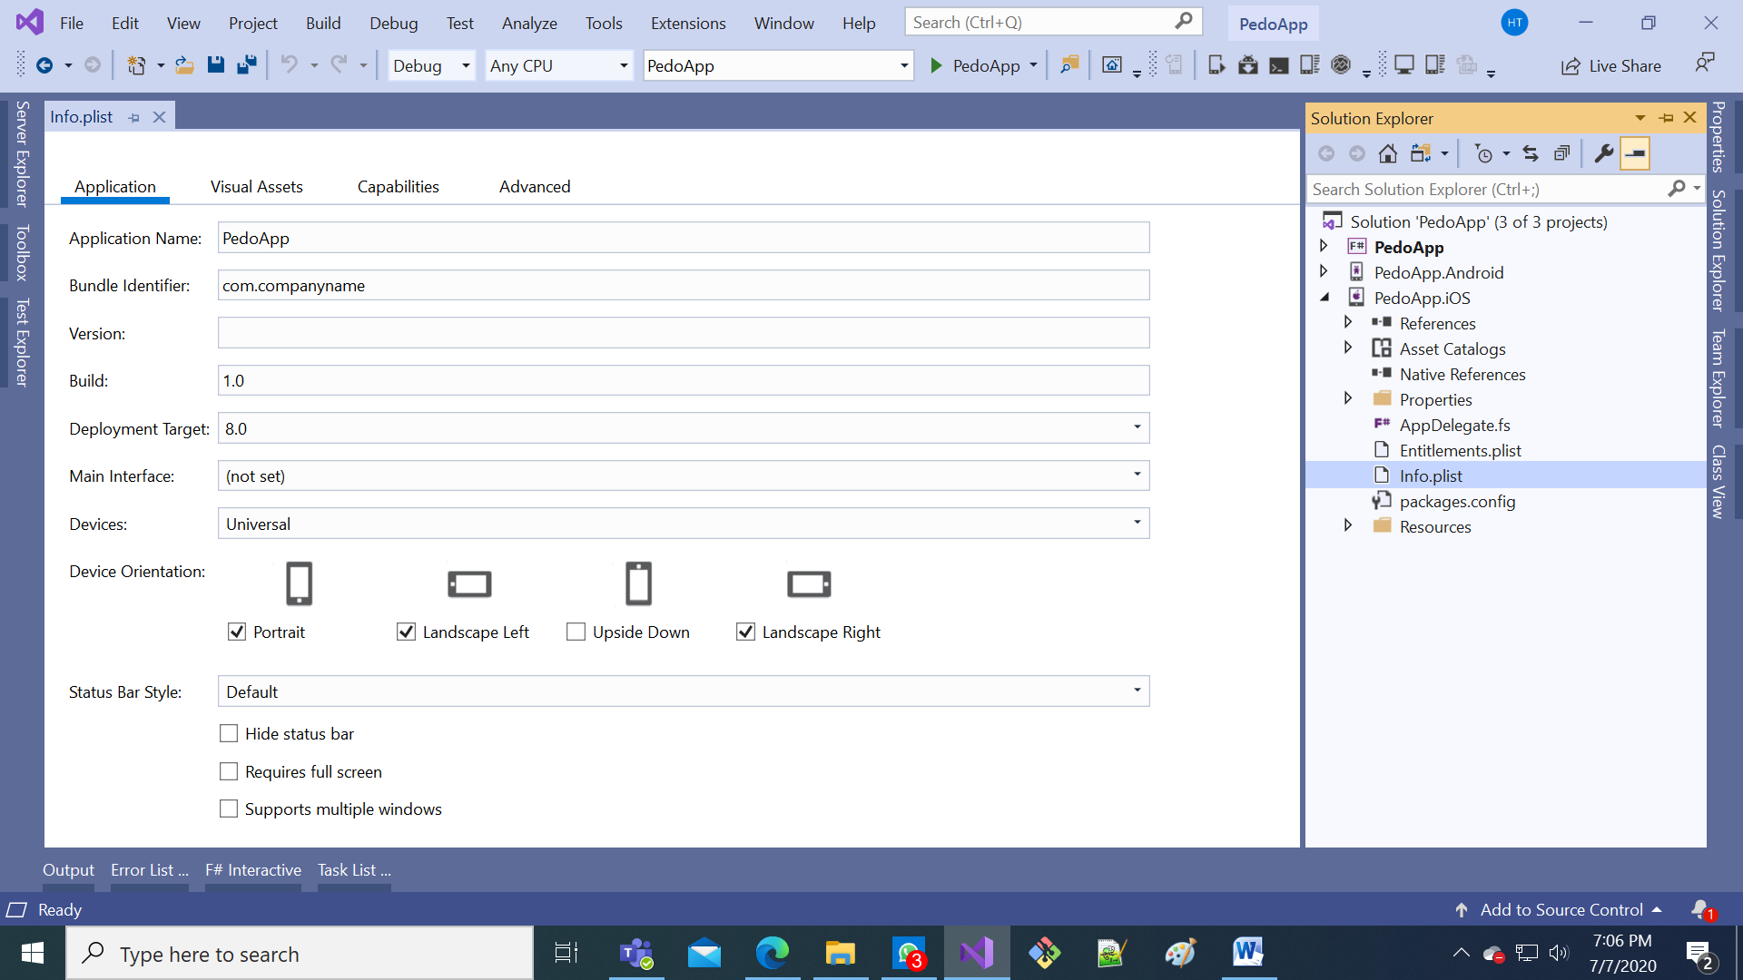

4

2

5

3

1

1. Back to the Mac, open your app's project settings by selecting its top-level node in Xcode's Project Navigator, then under General > Identity, replace the default Bundle Identifier with the one from above. This is because Xcode will only create a provisioning profile for an explicit App ID, and it must be identical to the App ID of your app. If they differ, you will not be able to use free provisioning to deploy your app.

1



2

3

4

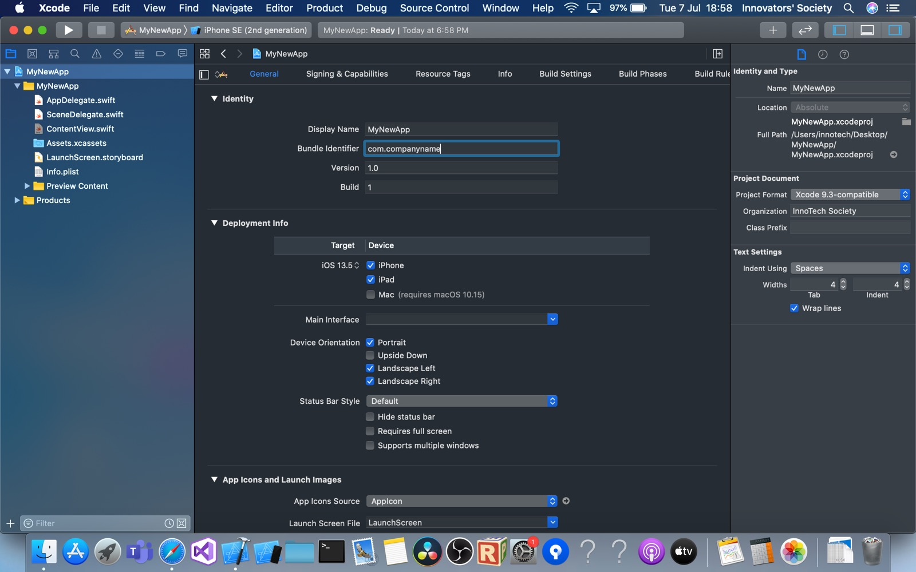

1. Under Deployment Info, ensure that the deployment target matches or is lower than the version of iOS installed on your connected iOS device
2. Under “Signing & Capabilities”, select “Automatically manage signing” and select your team from the drop-down list. If there is a failure when Xcode attempts to generate a provisioning profile, make sure that Xcode's currently-selected build scheme targets the connected iOS device rather than a simulator.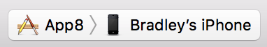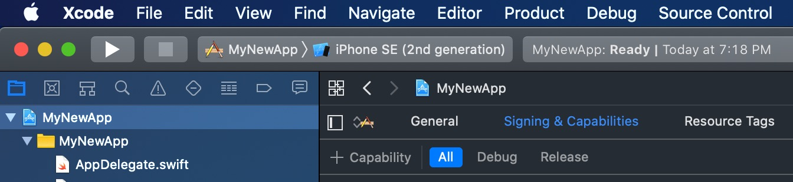

Success!

Fail!

1

3

2

1. Check that Xcode has automatically generated a provisioning profile and signing identity for you by clicking on the information icon next to provisioning profile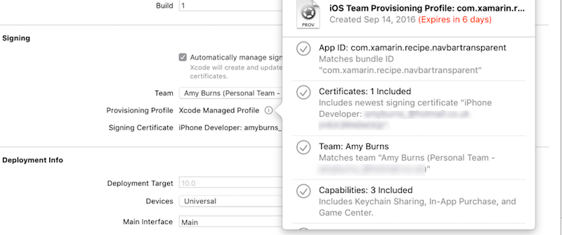
2. Test the provisioning profile in Xcode by deploying the blank application to your device with the run button

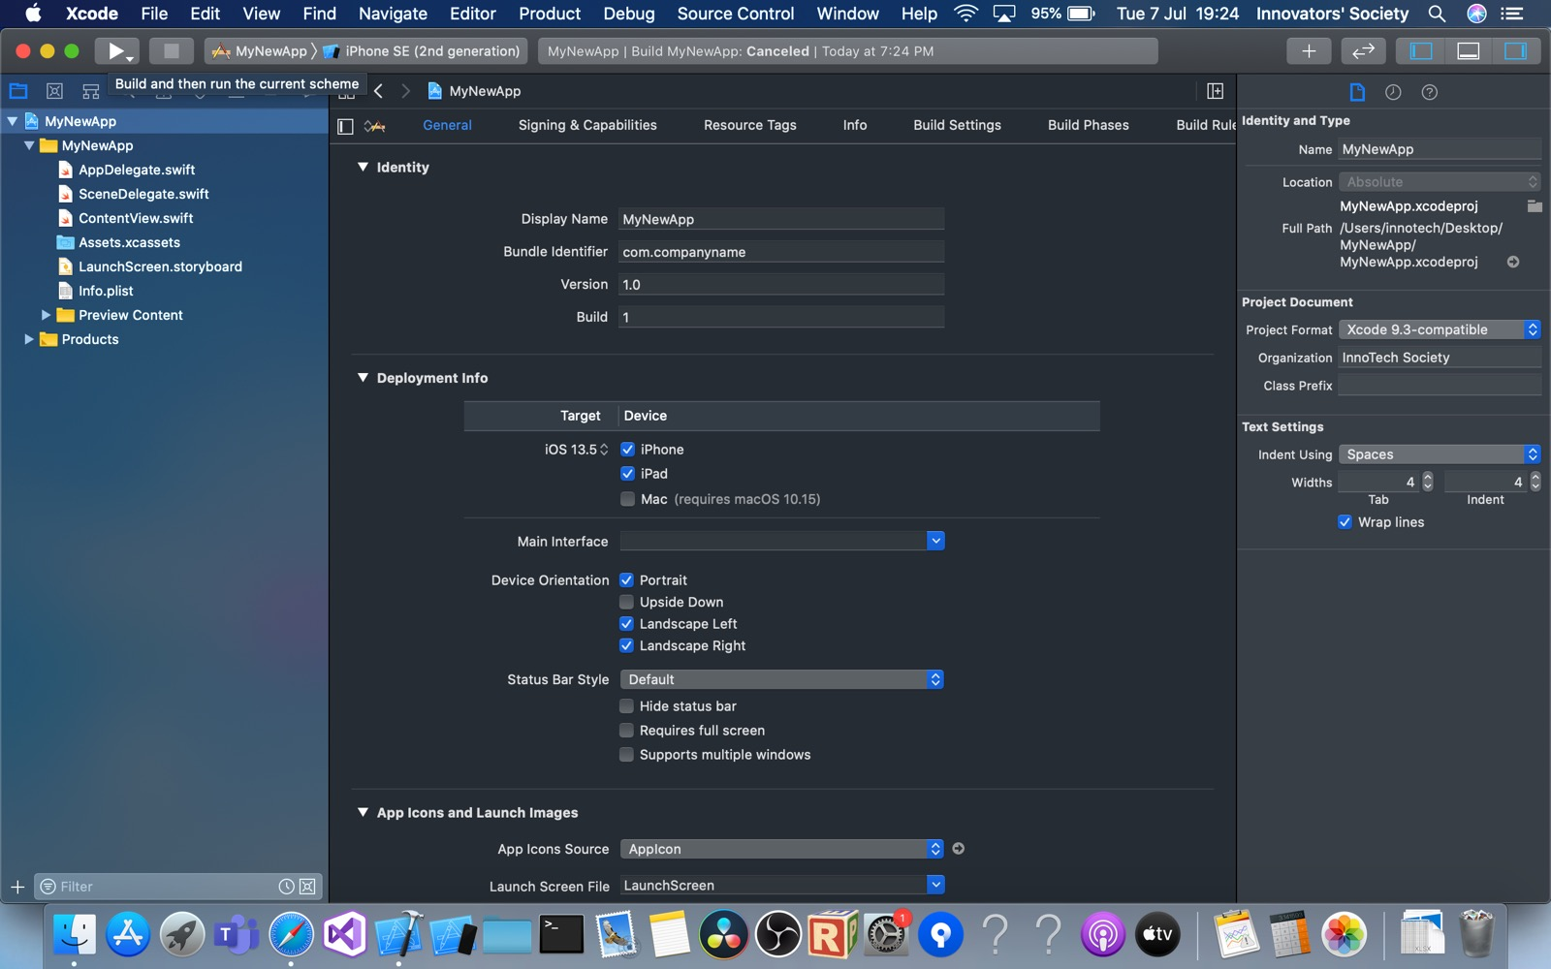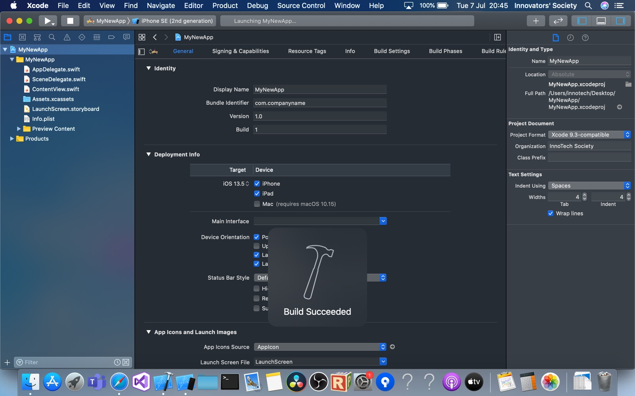

G. Run the app (iOS)

1. Ensure that you have gone through the Pair to Mac procedure
2. Ensure that your device has been connected to the Mac
3. In the Solution Explorer, right-click PedoApp.iOS and click properties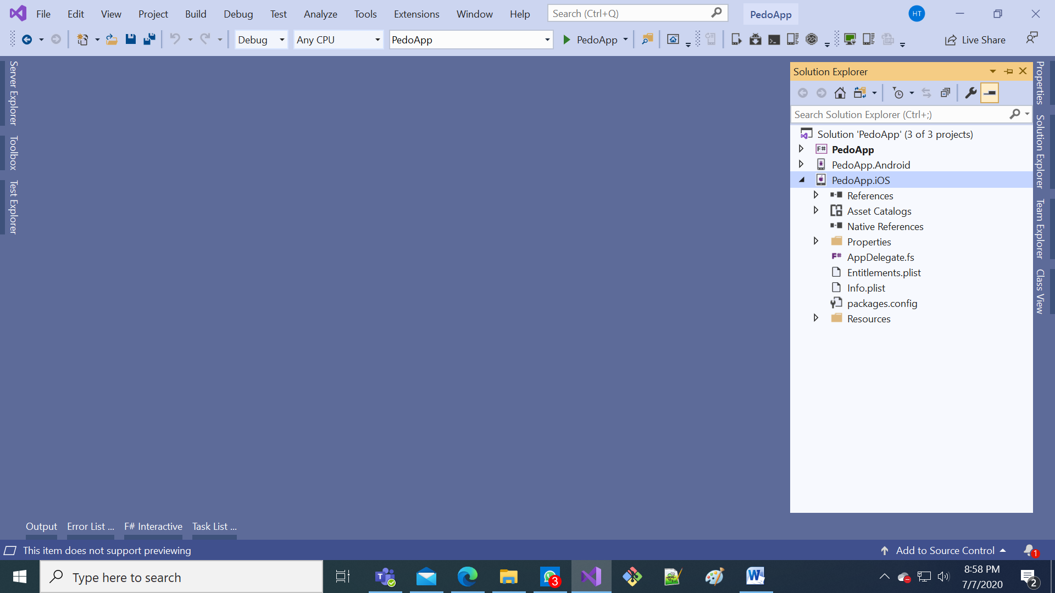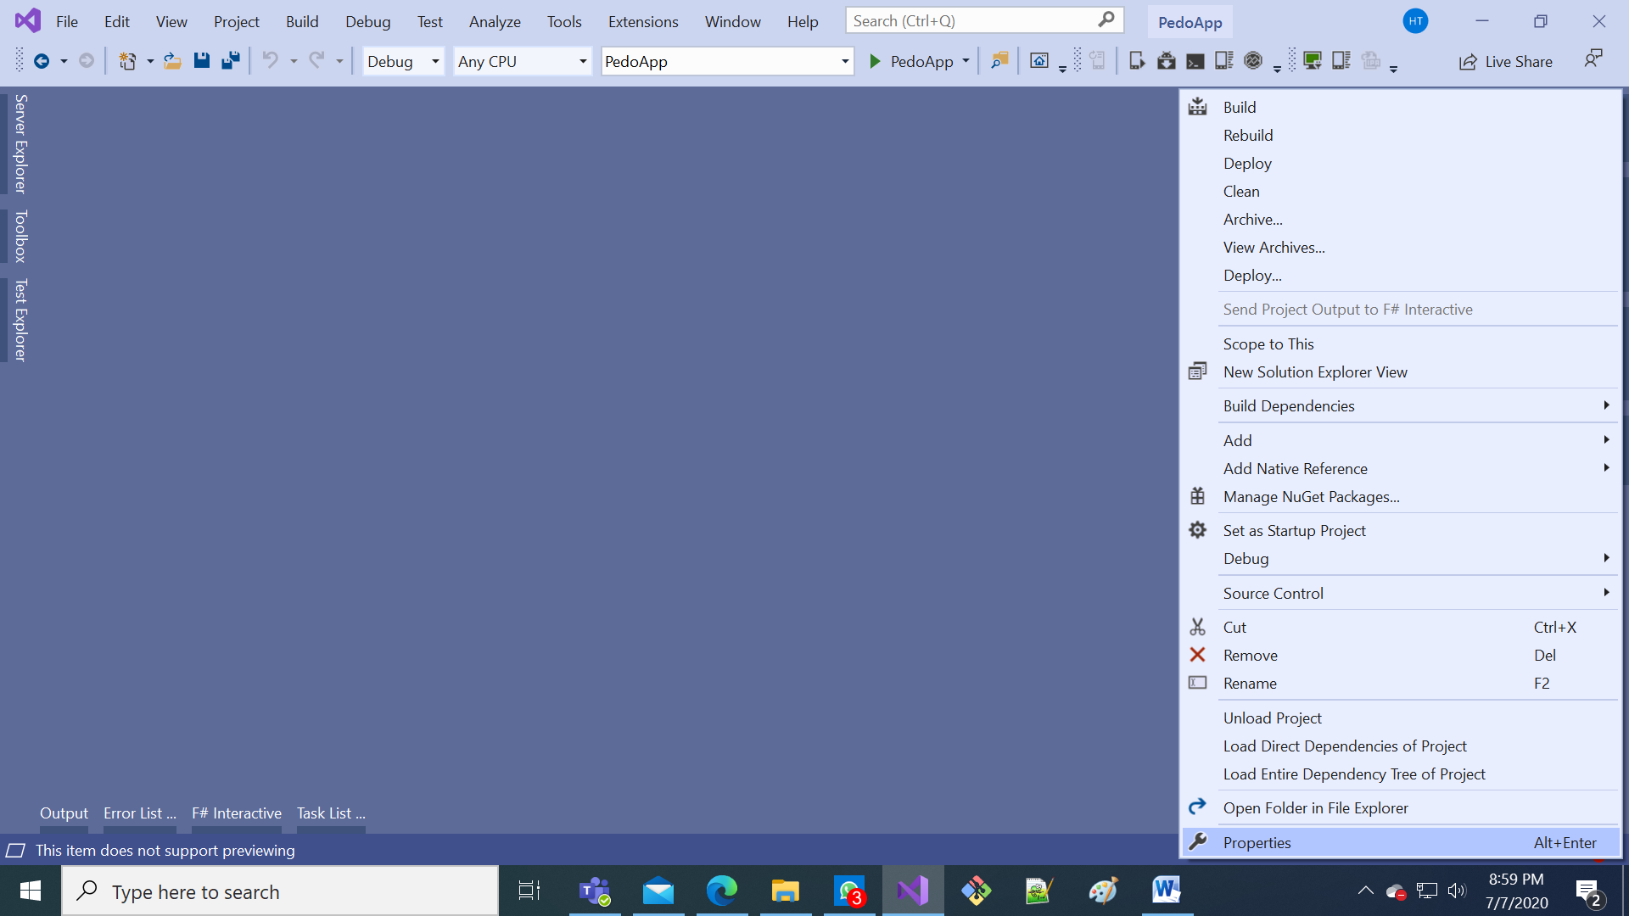

3

2

1

1. Select “iOS Bundle Signing”, choose “Manual provisioning”, select the Signing identity created by Xcode, and select the provisioning profile created by Xcode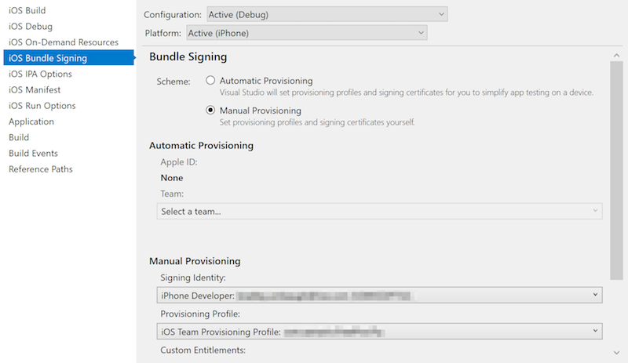

4

3

2

1

1. Save and close project properties  
   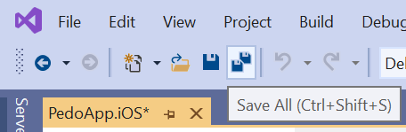

1

2

1

1. Select your iOS Device from the Target Device dropdown menu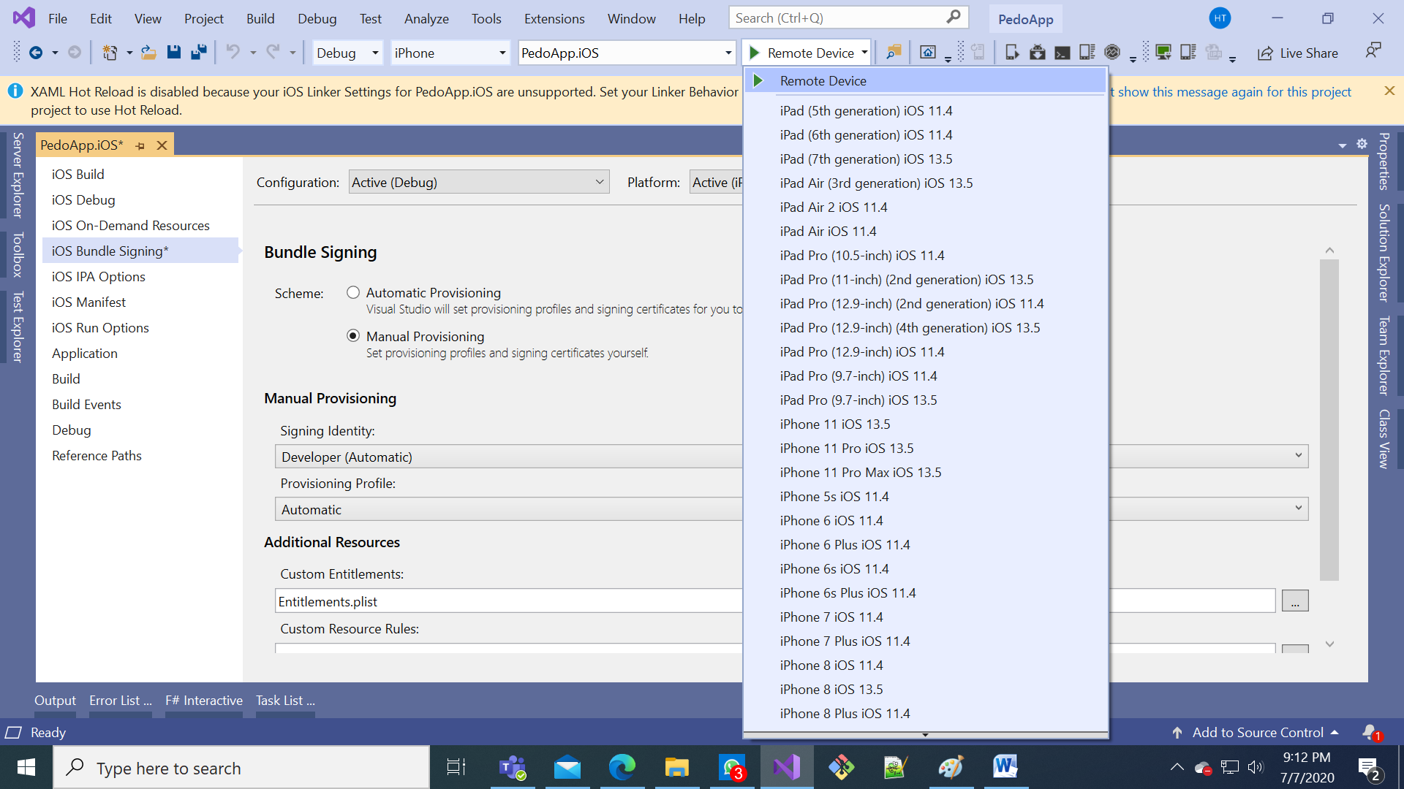

2

1. Click the green arrow to start debugging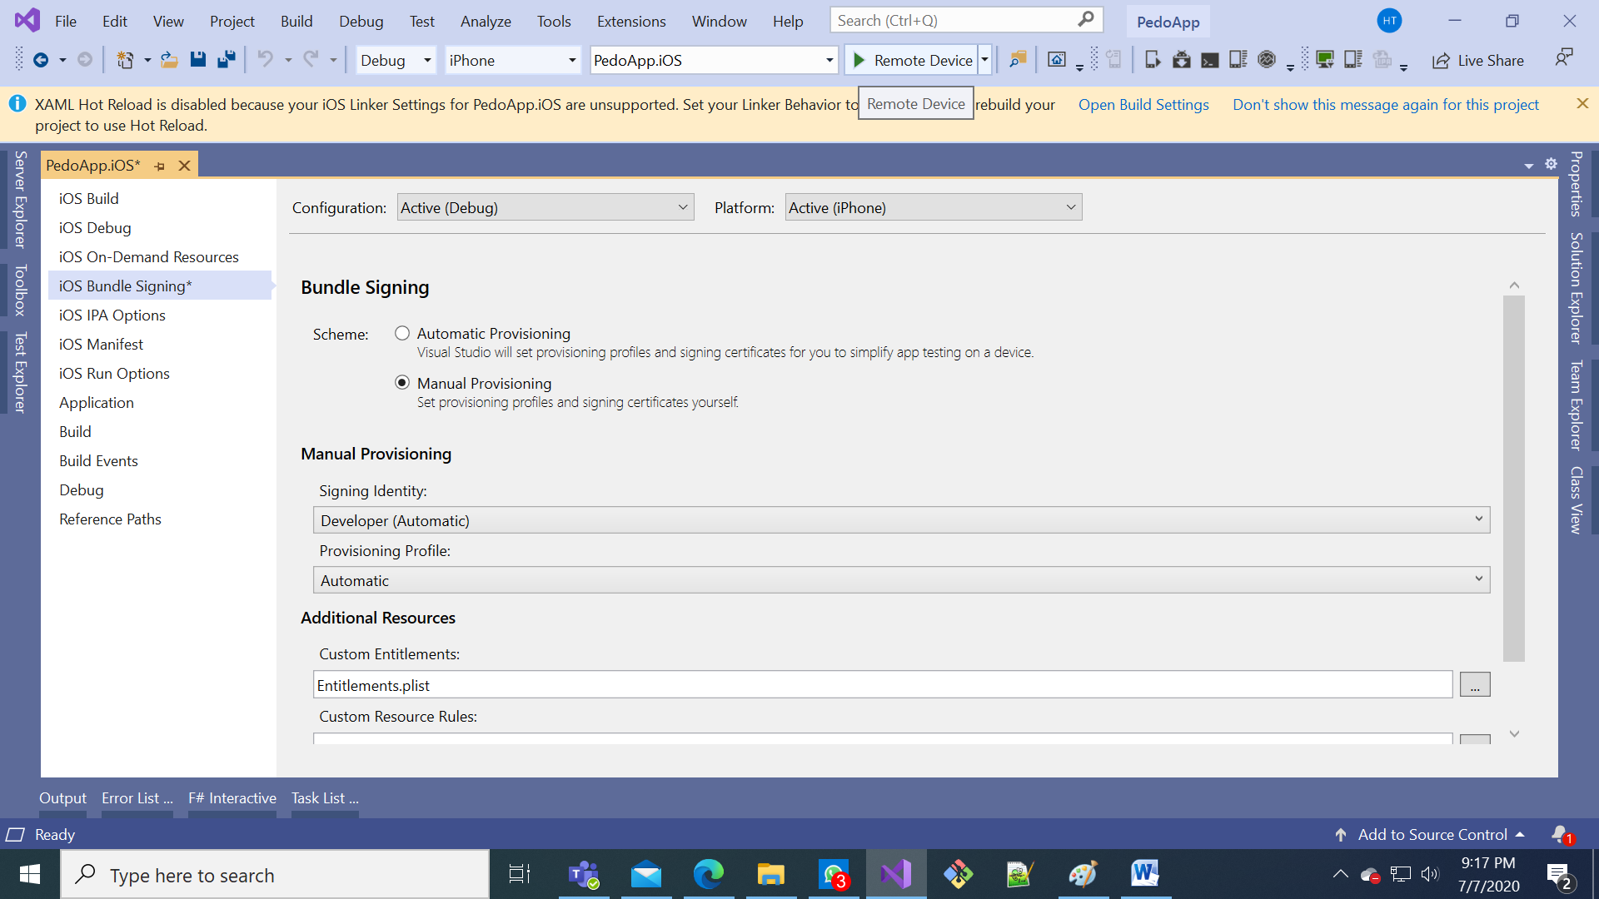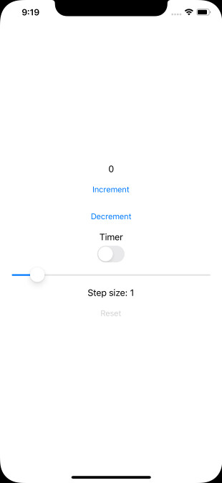

H. Adding a pedometer to the app

1. Remove red lines, add green lines in “PedoApp.fs”

...

open Xamarin.Forms

module App =

type Pedometer =

abstract Step : IEvent<int>

type Model =

{ Count : int

Step : int

TimerOn: bool }

TimerOn: bool

Pedometer : int }

type Msg =

| Increment

...

| SetStep of int

| TimerToggled of bool

| TimedTick

| PedometerUpdated of int

let initModel = { Count = 0; Step = 1; TimerOn=false }

let initModel = { Count = 0; Step = 1; TimerOn=false; Pedometer = 0 }

let init () = initModel, Cmd.none

let init () =

initModel, Cmd.ofSub (fun dispatch -> DependencyService.Get<Pedometer>().Step.Add(PedometerUpdated >> dispatch))

let timerCmd =

async { do! Async.Sleep 200

...

{ model with Count = model.Count + model.Step }, timerCmd

else

model, Cmd.none

| PedometerUpdated p -> { model with Pedometer = p }, Cmd.none

let view (model: Model) dispatch =

View.ContentPage(

...

View.Slider(minimumMaximum = (0.0, 10.0), value = double model.Step, valueChanged = (fun args -> dispatch (SetStep (int (args.NewValue + 0.5)))), horizontalOptions = LayoutOptions.FillAndExpand)

View.Label(text = sprintf "Step size: %d" model.Step, horizontalOptions = LayoutOptions.Center)

View.Button(text = "Reset", horizontalOptions = LayoutOptions.Center, command = (fun () -> dispatch Reset), commandCanExecute = (model <> initModel))

View.Label(text = sprintf "Pedometer: %d" model.Pedometer)

]))

// Note, this declaration is needed if you enable LiveUpdate

Open “MainActivity.fs” under “PedoApp.Android” (remember this as “MainActivity.fs”): 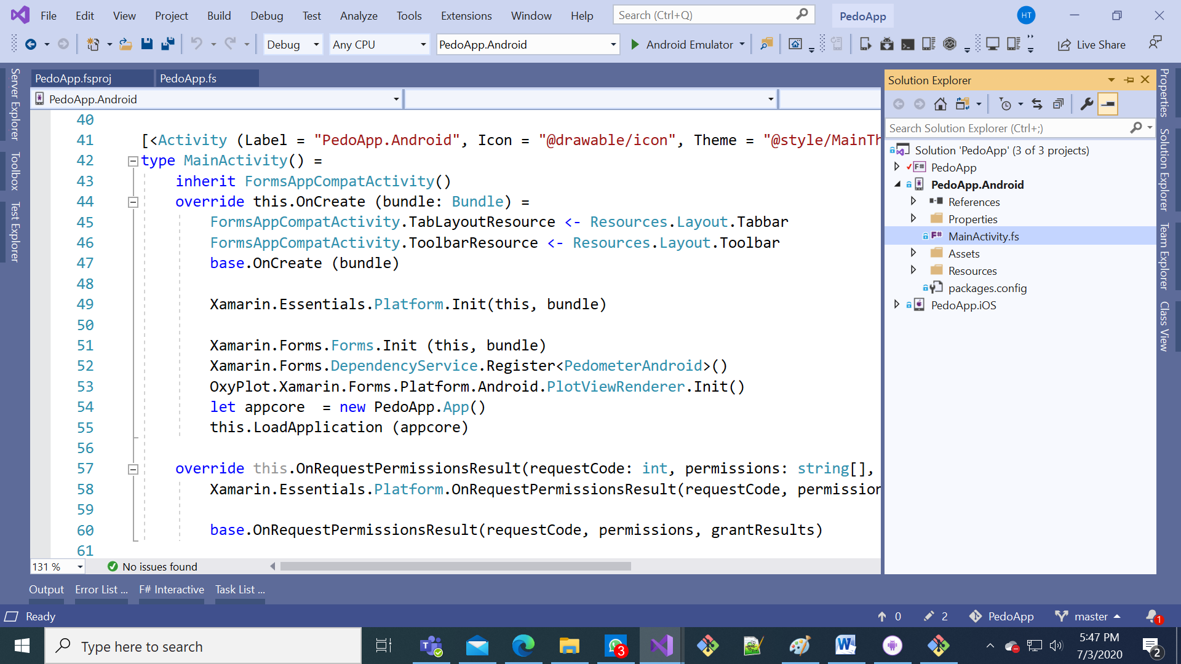

1. Remove red lines, add green lines in “MainActivity.fs”

...

open Android.OS

open Xamarin.Forms.Platform.Android

type PedometerListener(onChanged) =

inherit Java.Lang.Object()

interface Android.Hardware.ISensorEventListener with

member _.OnAccuracyChanged(_, _) = ()

member _.OnSensorChanged e =

// steps since device boot

onChanged <| int e.Values.[0]

type PedometerAndroid() =

let manager =

Context.SensorService

|> Xamarin.Essentials.Platform.CurrentActivity.GetSystemService

:?> Android.Hardware.SensorManager

let sensor = manager.GetDefaultSensor Android.Hardware.SensorType.StepCounter

let event = Event<int>()

do manager.RegisterListener(new PedometerListener(event.Trigger), sensor, Android.Hardware.SensorDelay.Fastest)

|> ignore

interface PedoApp.App.Pedometer with member _.Step = event.Publish

[<UsesPermission("android.permission.ACTIVITY_RECOGNITION")>]

[<UsesFeature(Name=Android.Hardware.Sensor.StringTypeStepCounter, Required=true)>]

do ()

[<Activity (Label = "PedoApp.Android", Icon = "@drawable/icon", Theme = "@style/MainTheme", MainLauncher = true, ConfigurationChanges = (ConfigChanges.ScreenSize ||| ConfigChanges.Orientation))>]

type MainActivity() =

inherit FormsAppCompatActivity()

...

Xamarin.Essentials.Platform.Init(this, bundle)

Xamarin.Forms.Forms.Init (this, bundle)

Xamarin.Forms.DependencyService.Register<PedometerAndroid>()

let appcore = new PedoApp.App()

this.LoadApplication (appcore)

Open “AppDelegate.fs” under “PedoApp.iOS” (remember this as “AppDelegate.fs”): 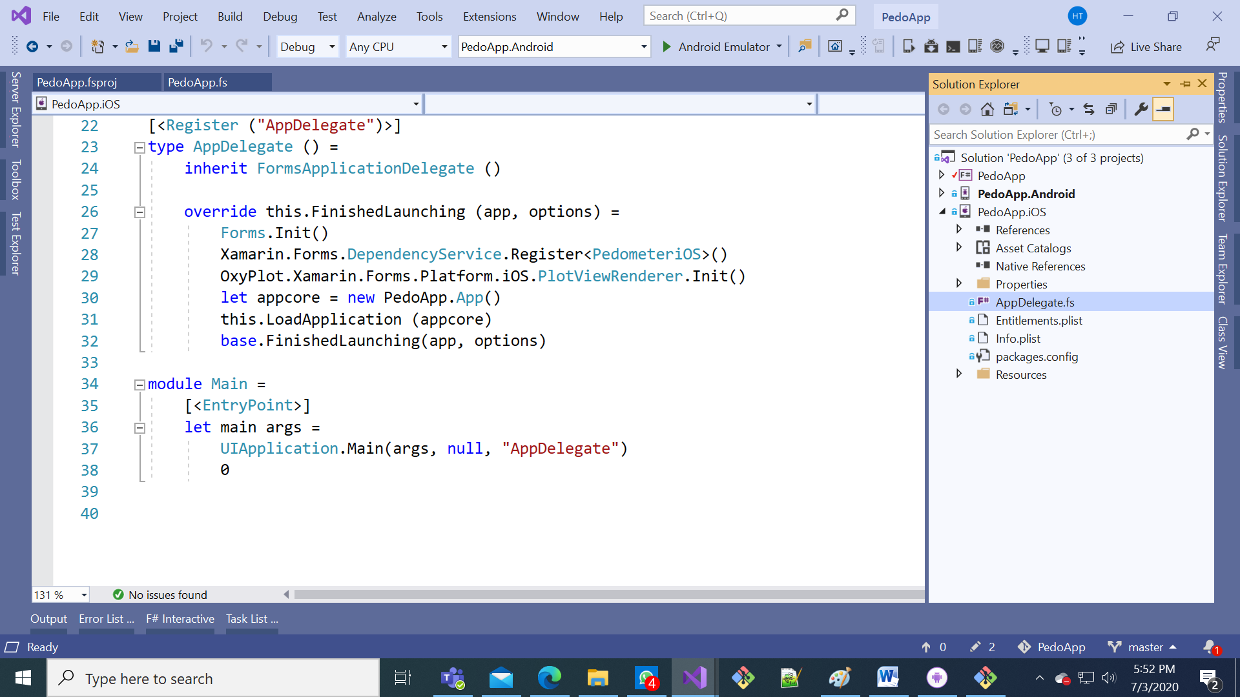

1. Remove red lines, add green lines in “AppDelegate.fs”

...

open Xamarin.Forms

open Xamarin.Forms.Platform.iOS

type PedometeriOS() =

let pedometer = new CoreMotion.CMPedometer()

let event = Event<int>()

// steps from midnight

do pedometer.StartPedometerUpdates(DateTime.Today.ToNSDate(),

Action<_, _>(fun data _ -> event.Trigger data.NumberOfSteps.Int32Value))

interface PedoApp.App.Pedometer with member _.Step = event.Publish

[<Register ("AppDelegate")>]

type AppDelegate () =

inherit FormsApplicationDelegate ()

...

override this.FinishedLaunching (app, options) =

Forms.Init()

Xamarin.Forms.DependencyService.Register<PedometeriOS>()

1. Run the app

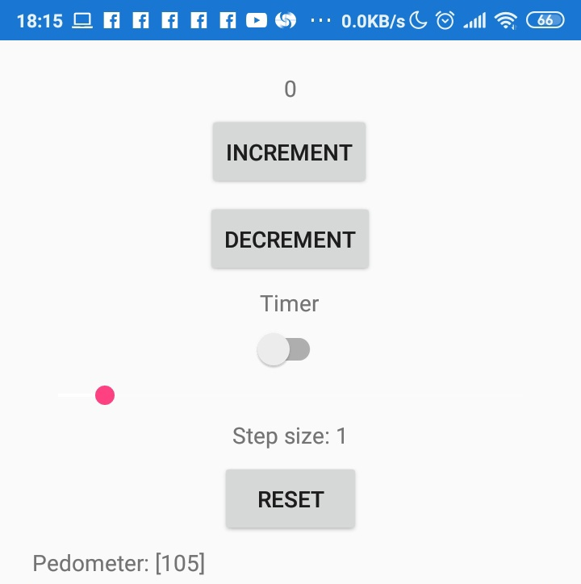

The data updates every minute because the sensor stabilizes the data to improve accuracy.

But for iOS, we cannot see the data! Why?

The answer is that iOS 10 has updated privacy policy and implemented new privacy rules. We have to provide a description for how we would use the pedometer data.

I. Fixing the iOS pedometer

1. In the Solution Explorer, right-click Info.plist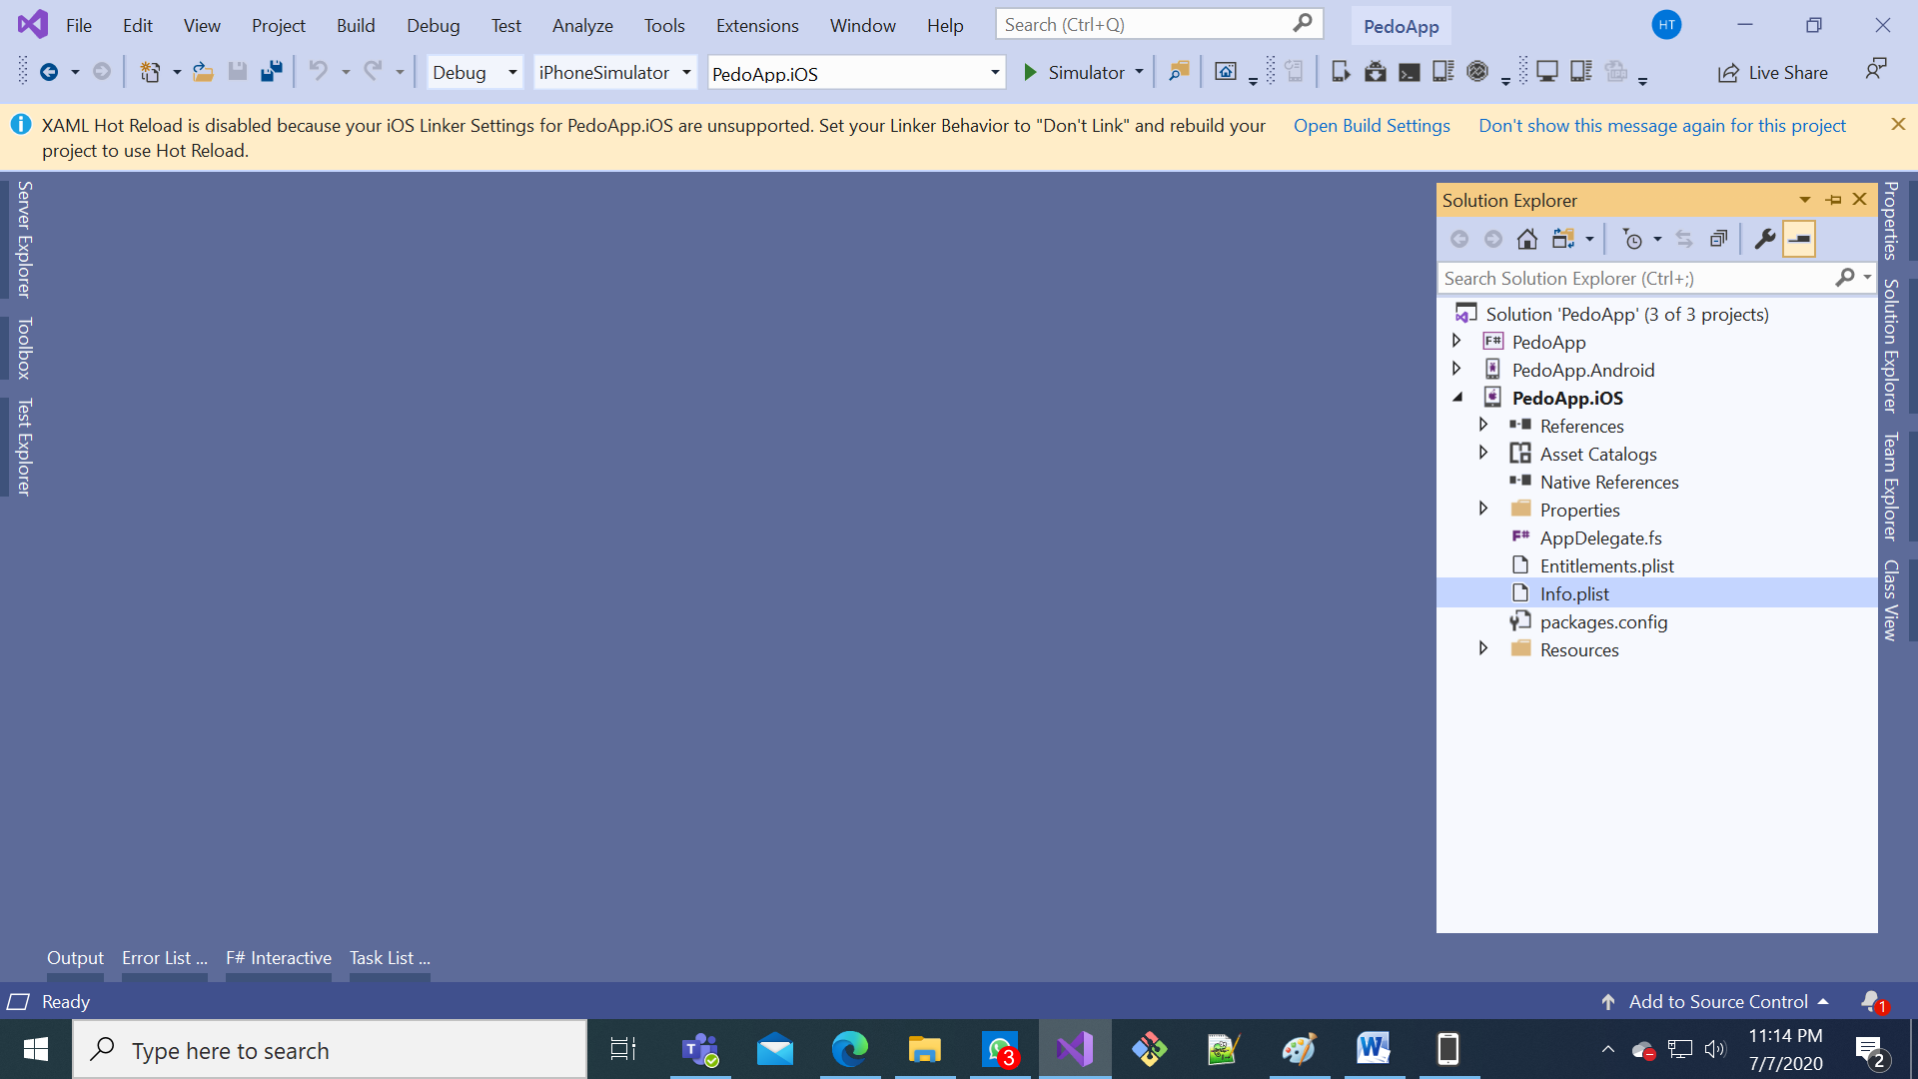

2

1

1. Select Open With…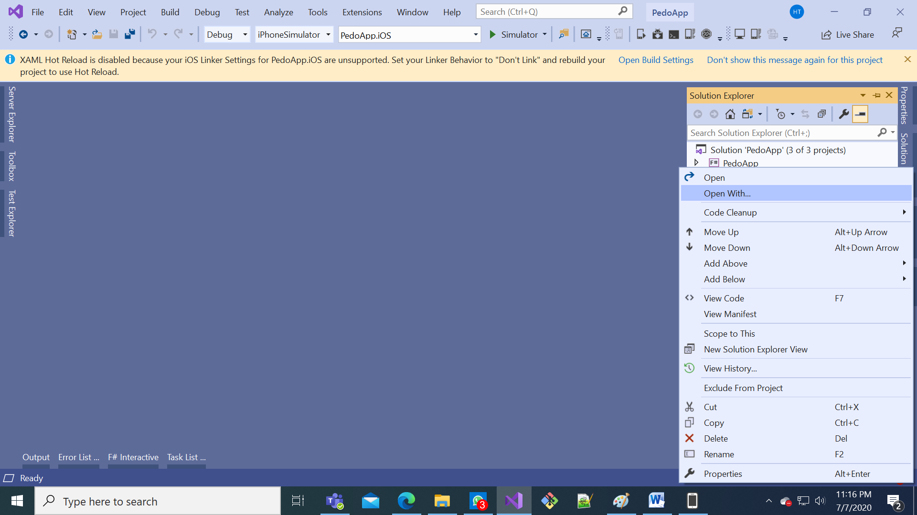
2. Select “Generic PList Editor” and click OK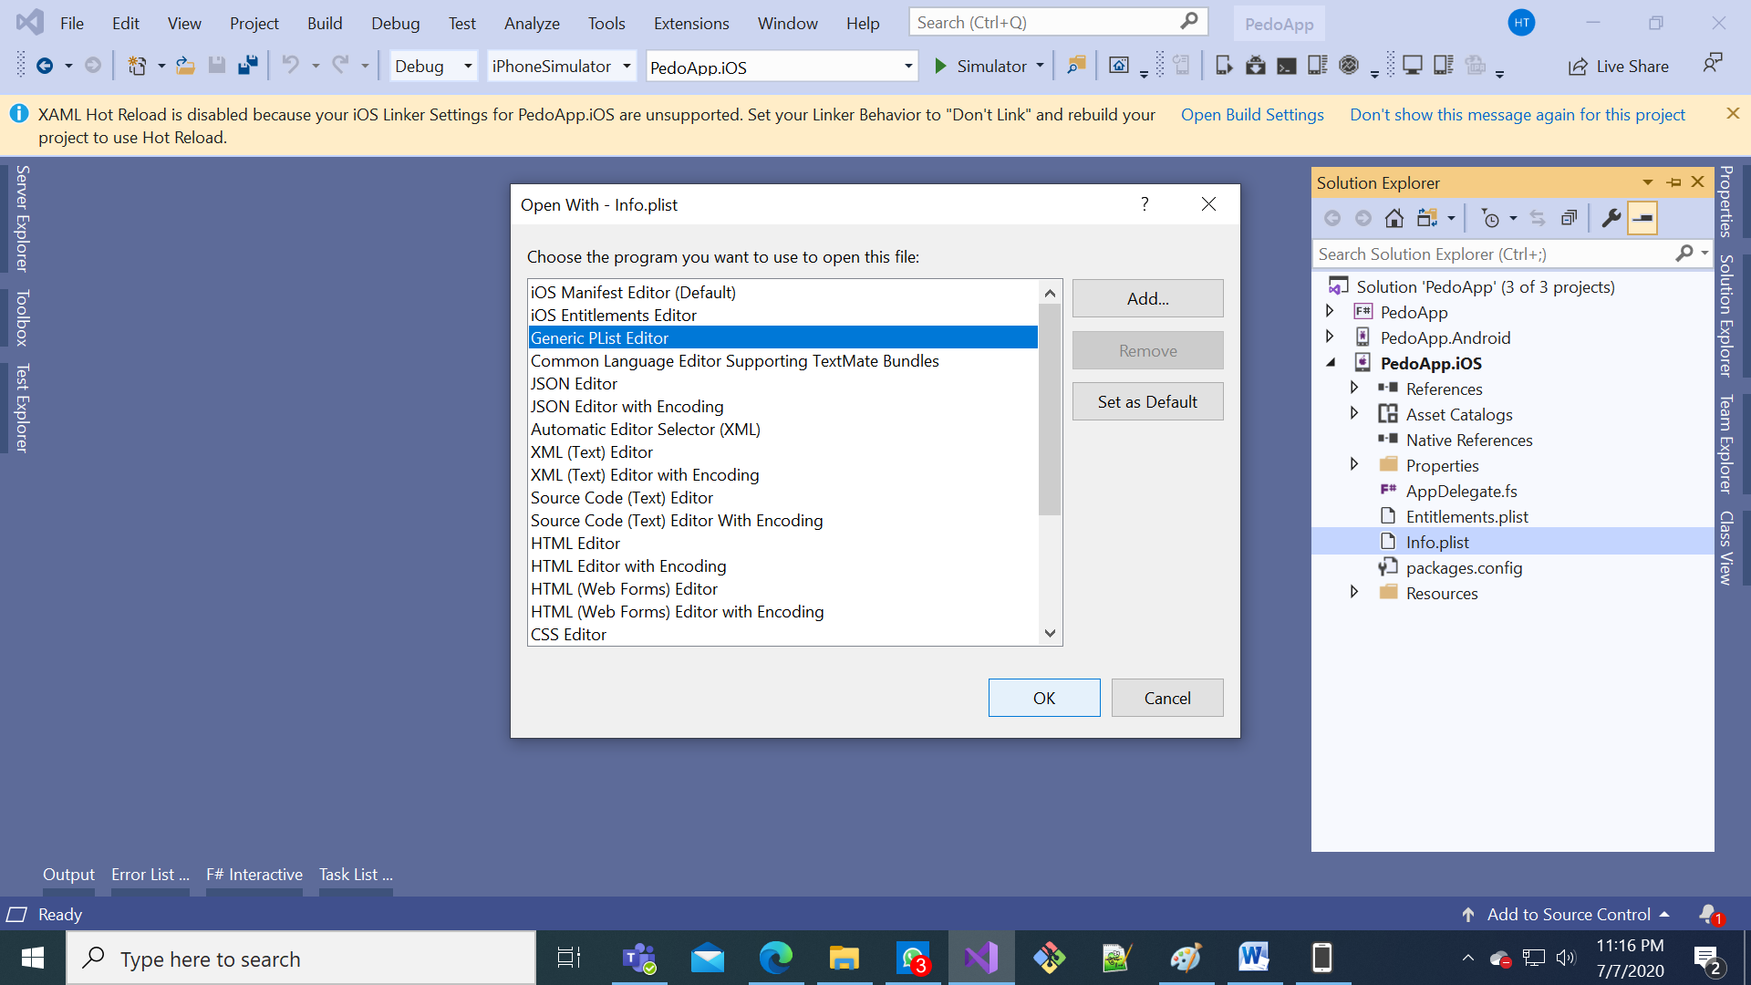

2

1

1. Scroll to the bottom and click +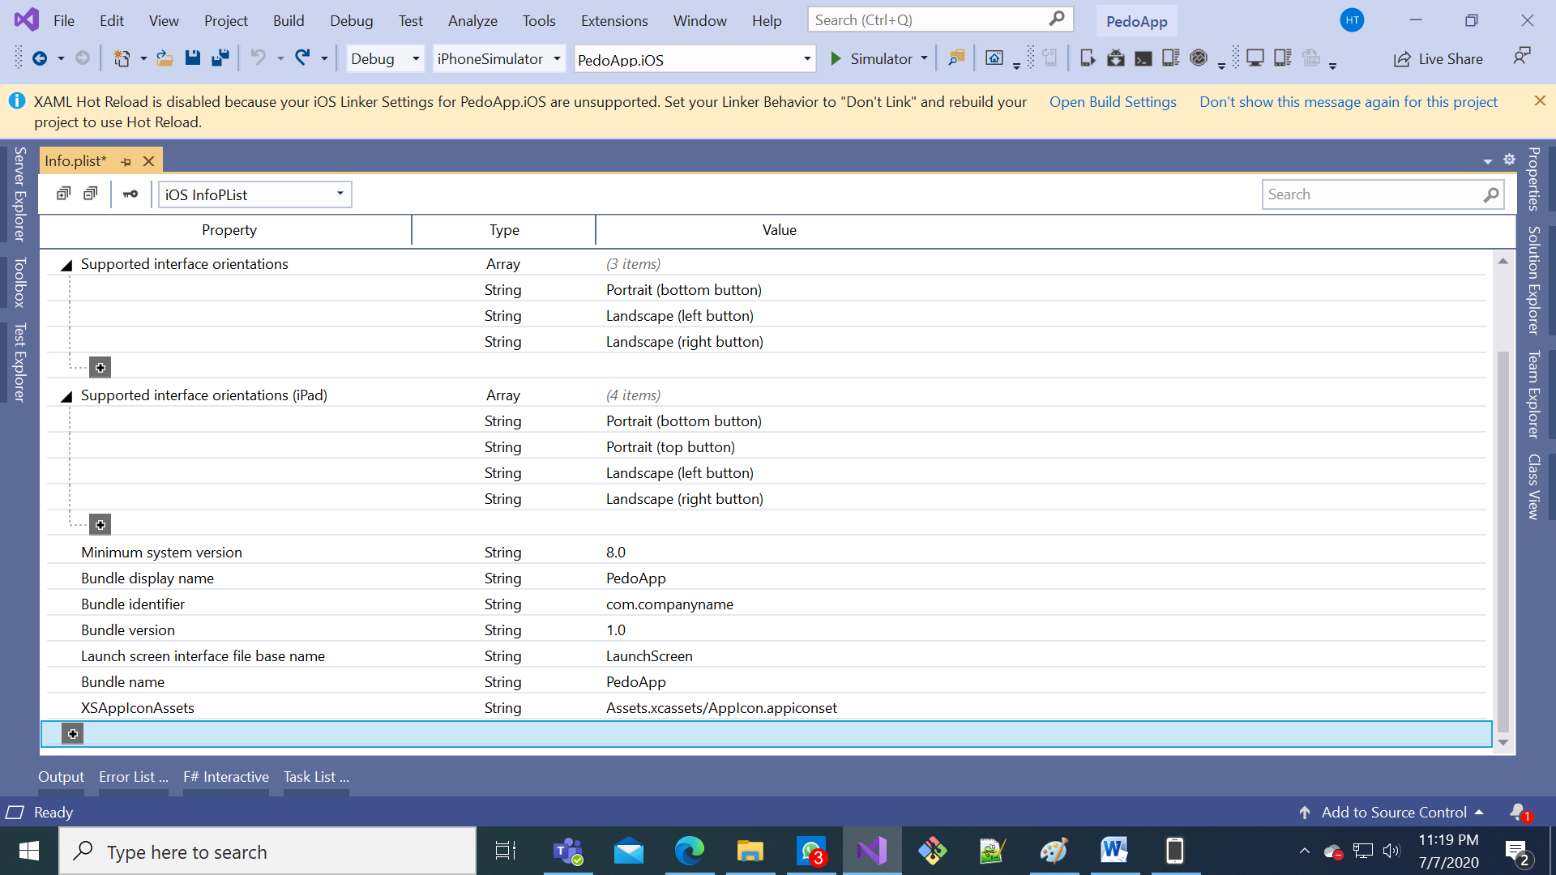

2

1

1. Click on the CustomProperty text you have just created then scroll to and select “Privacy - Motion Usage Description”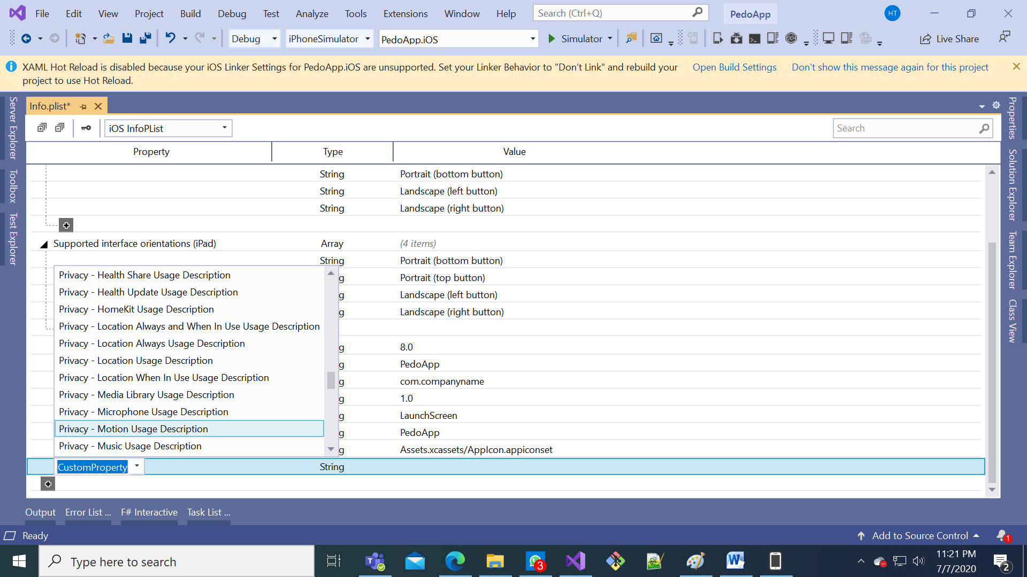

3

2

1

1. Click the space on the row you just created and the column “Value”, and then input  
   The pedometer needs to be accessed to track your steps.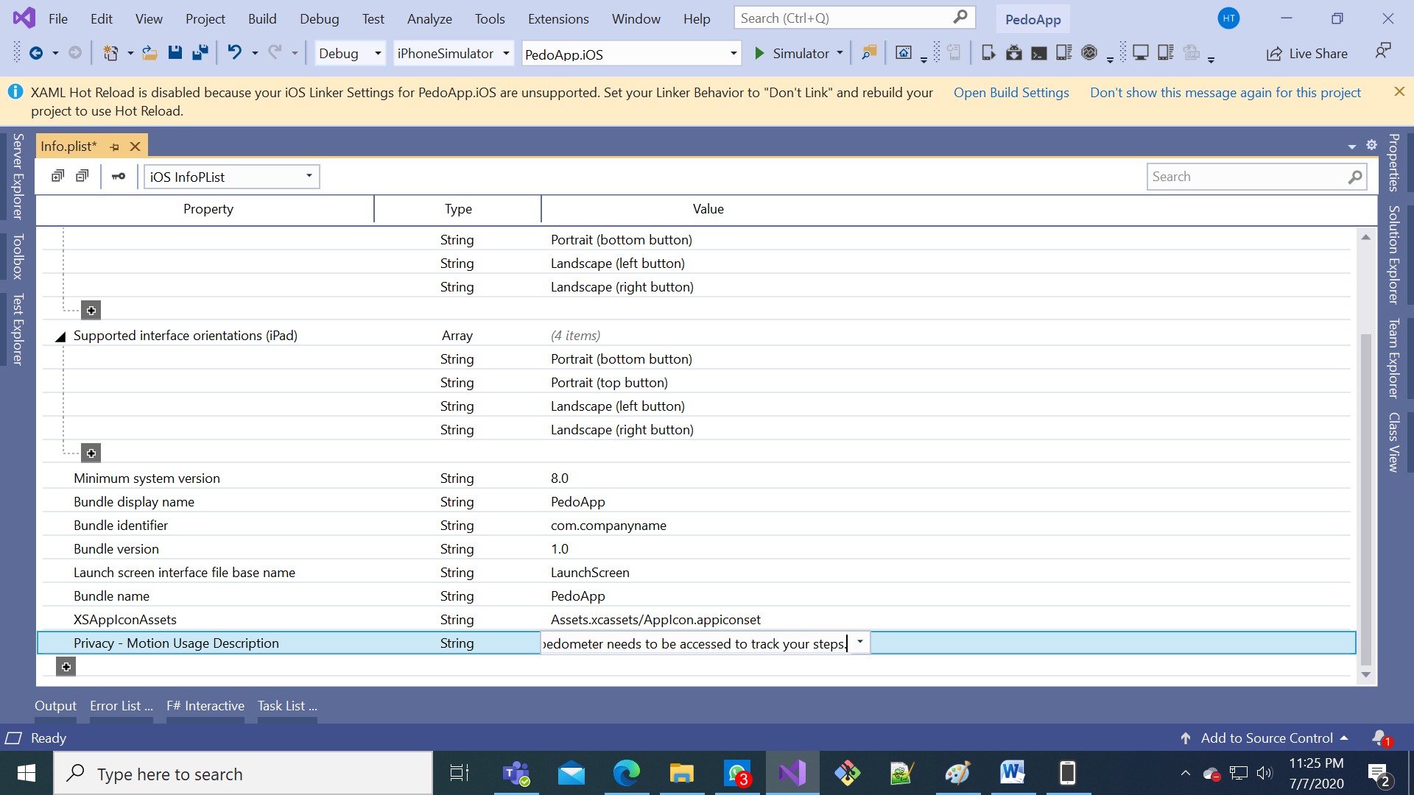
2. Save the changes by clicking the save icon, then close Info.plist  
   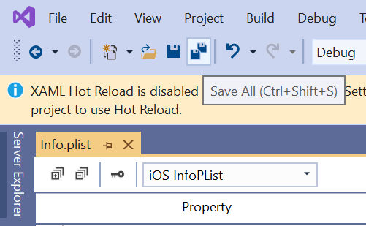

2

1

1. Debug on your device again by clicking the green arrow
2. On the phone, click OK on the popup (below is how it would look like on another app)  
   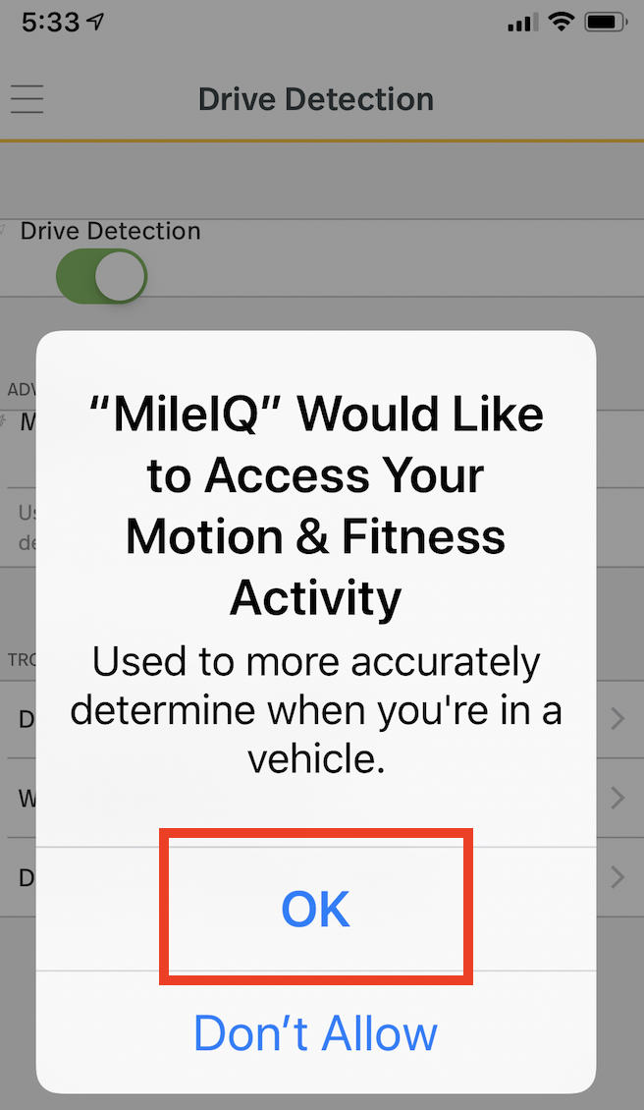

J. Checking pedometer availability

1. Remove red lines, add green lines in “PedoApp.fs”

...

module App =

type Pedometer =

abstract IsSupported : bool

abstract Step : IEvent<int>

type Model =

{ Count : int

...

let initModel = { Count = 0; Step = 1; TimerOn=false; Pedometer = [] }

let init () =

initModel, Cmd.ofSub (fun dispatch -> DependencyService.Get<Pedometer>().Step.Add(PedometerUpdated >> dispatch))

initModel, Cmd.ofSub (fun dispatch ->

let pedometer = DependencyService.Get<Pedometer>()

if pedometer.IsSupported then

pedometer.Step.Add(PedometerUpdated >> dispatch)

else Xamarin.Forms.Application.Current.MainPage.DisplayAlert("Oh no", "Pedometer is not supported", "Ok")

|> ignore

)

let timerCmd =

async { do! Async.Sleep 200

1. Remove red lines, add green lines in “MainActivity.fs”

...

:?> Android.Hardware.SensorManager

let sensor = manager.GetDefaultSensor Android.Hardware.SensorType.StepCounter

let event = Event<int>()

do manager.RegisterListener(new PedometerListener(event.Trigger), sensor, Android.Hardware.SensorDelay.Fastest)

|> ignore

interface PedoApp.App.Pedometer with member _.Step = event.Publish

do

if sensor <> null then

manager.RegisterListener(new PedometerListener(event.Trigger), sensor, Android.Hardware.SensorDelay.Fastest)

|> ignore

interface PedoApp.App.Pedometer with

member _.IsSupported = sensor <> null

member _.Step = event.Publish

[<UsesPermission("android.permission.ACTIVITY_RECOGNITION")>]

[<UsesFeature(Name=Android.Hardware.Sensor.StringTypeStepCounter, Required=true)>]

do ()

1. Remove red lines, add green lines in “AppDelegate.fs”

...

let pedometer = new CoreMotion.CMPedometer()

let event = Event<int>()

// steps from midnight

do pedometer.StartPedometerUpdates(DateTime.Today.ToNSDate(),

Action<_, _>(fun data _ -> event.Trigger data.NumberOfSteps.Int32Value))

interface PedoApp.App.Pedometer with member _.Step = event.Publish

do

if CoreMotion.CMPedometer.IsStepCountingAvailable then

pedometer.StartPedometerUpdates(DateTime.Today.ToNSDate(),

Action<_, _>(fun data _ -> event.Trigger data.NumberOfSteps.Int32Value))

interface PedoApp.App.Pedometer with

member _.IsSupported = CoreMotion.CMPedometer.IsStepCountingAvailable

member _.Step = event.Publish

[<Register ("AppDelegate")>]

type AppDelegate () =

K. Graphing the data

1. In Solution Explorer, right-click Solution ‘PedoApp’ 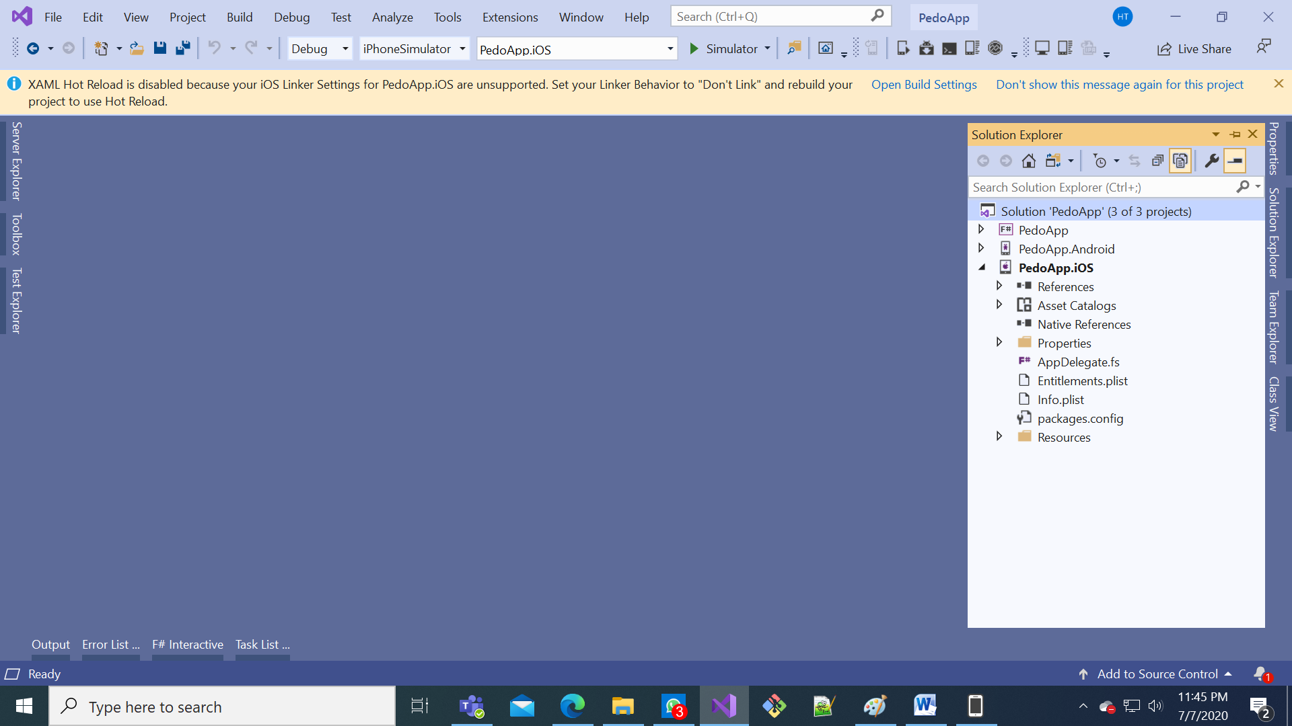

2

1

1. Select “Manage NuGet Packages for Soluion…”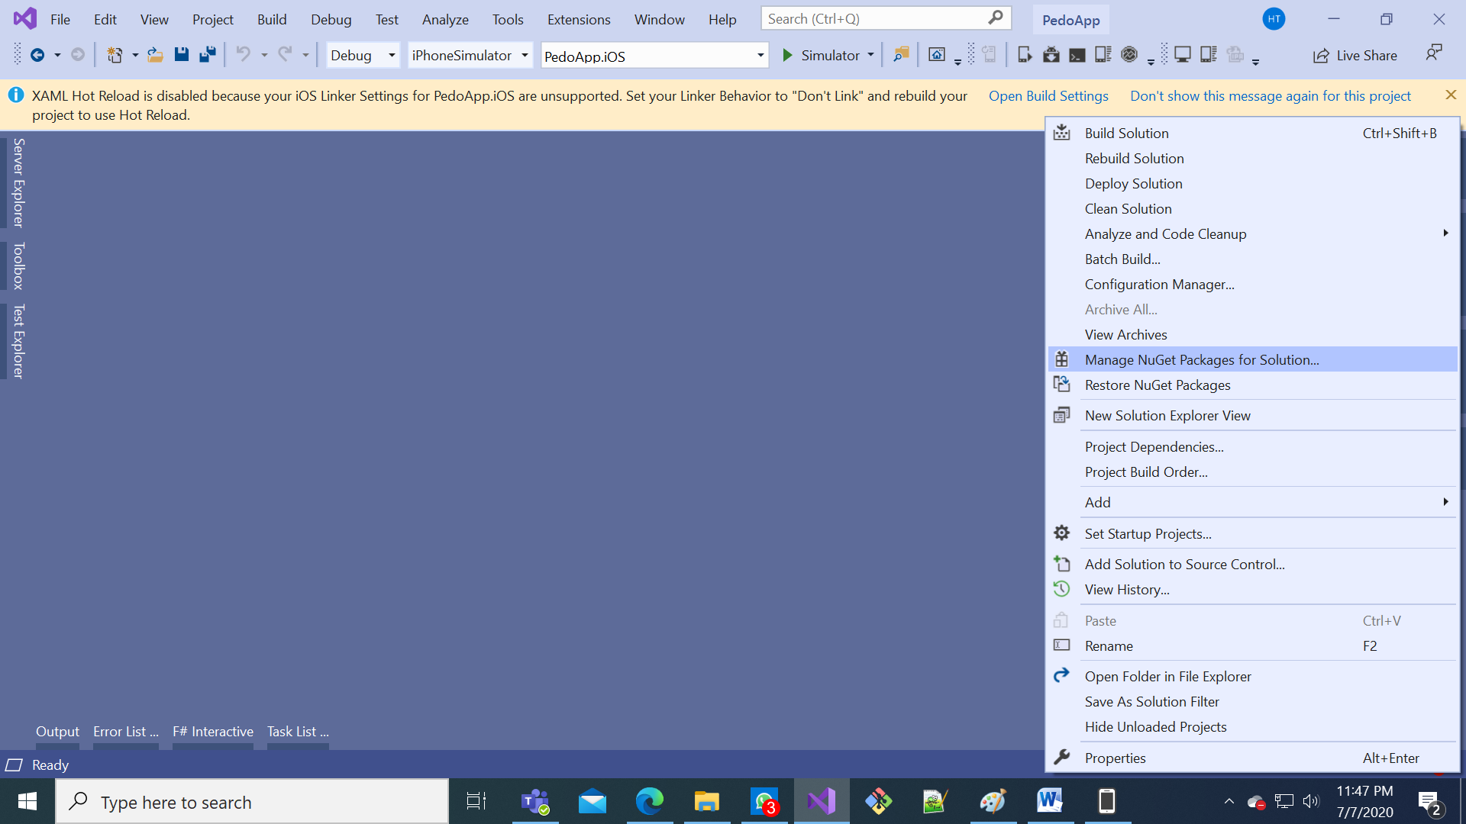
2. Select tab “Browse”, then uncheck “Include prerelease” and input Fabulous.XamarinForms.OxyPlot as the search package, then select the first package and check the checkbox to the left of “Project”, finally click Install

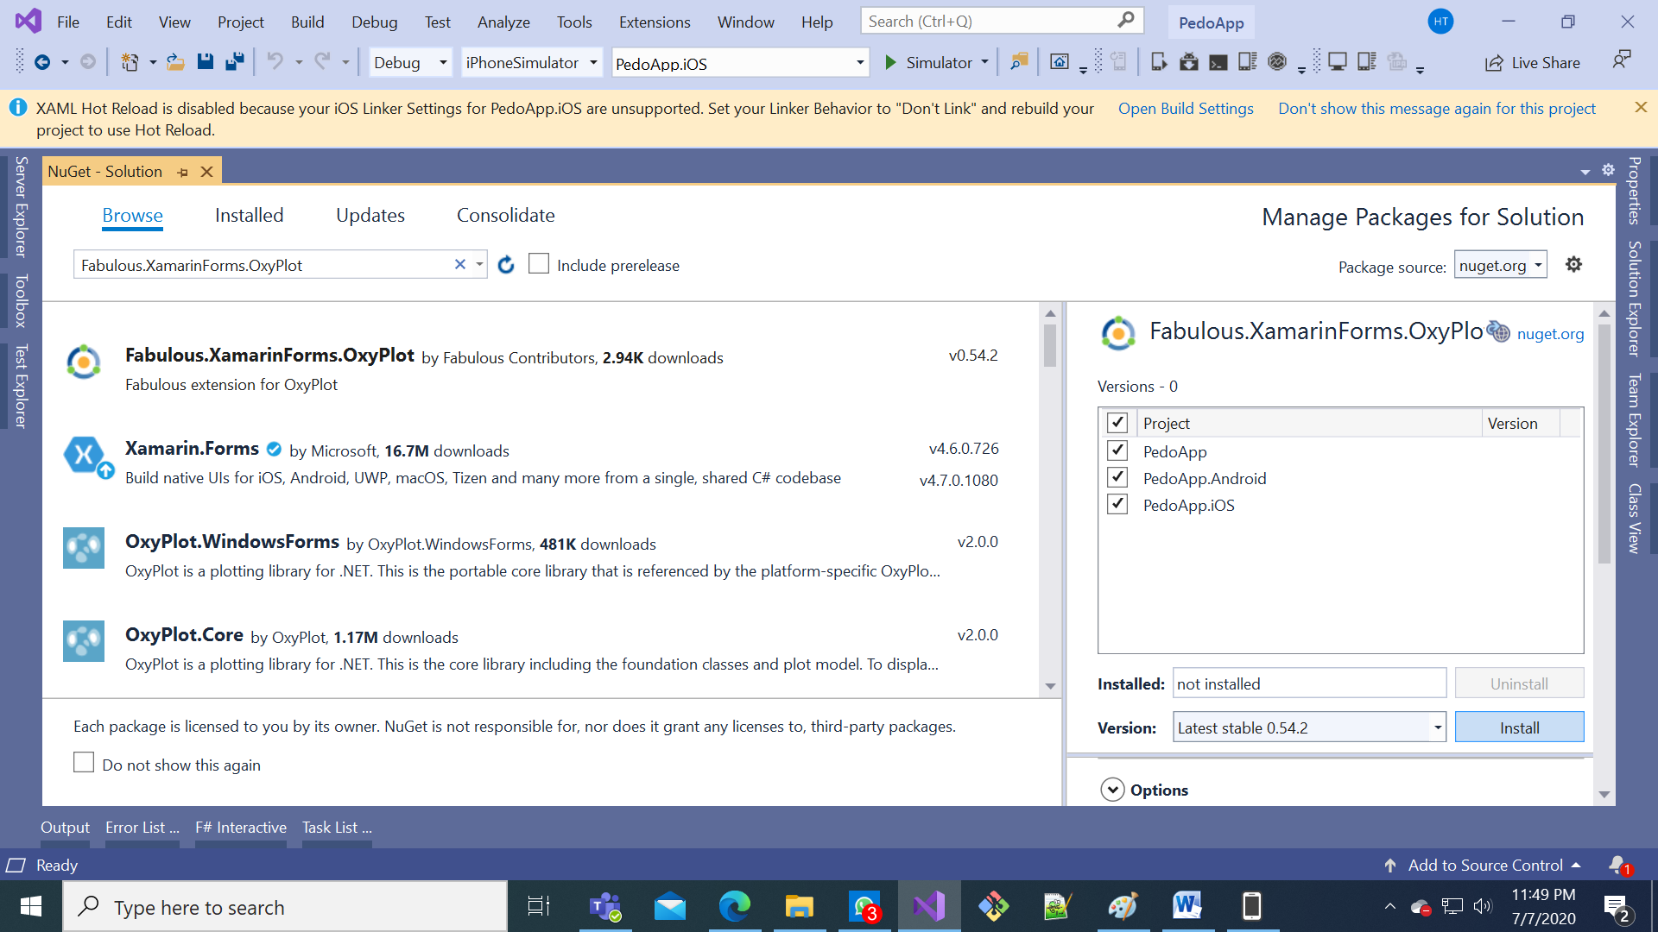

5

4

2

3

6

1

1. In the Preview Changes dialog, click OK to install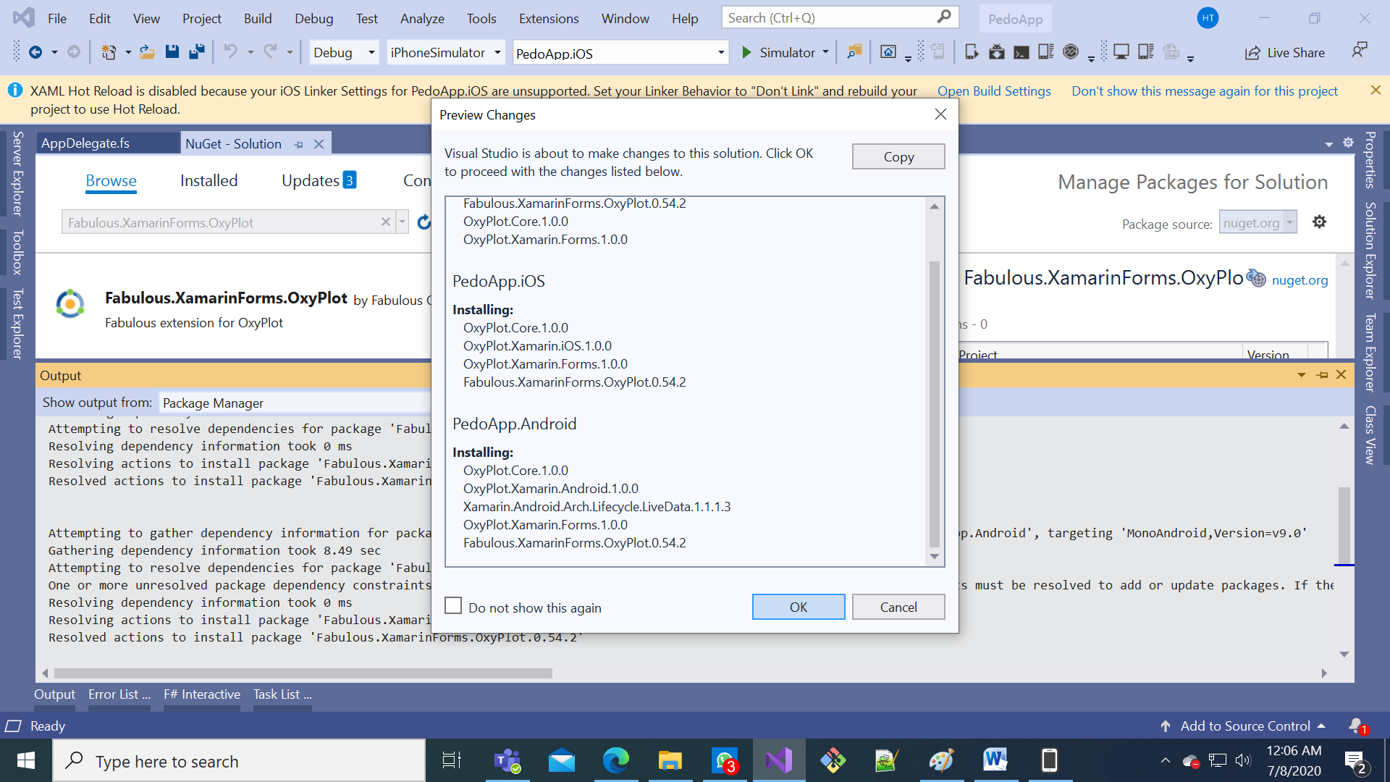
2. Accept the package licenses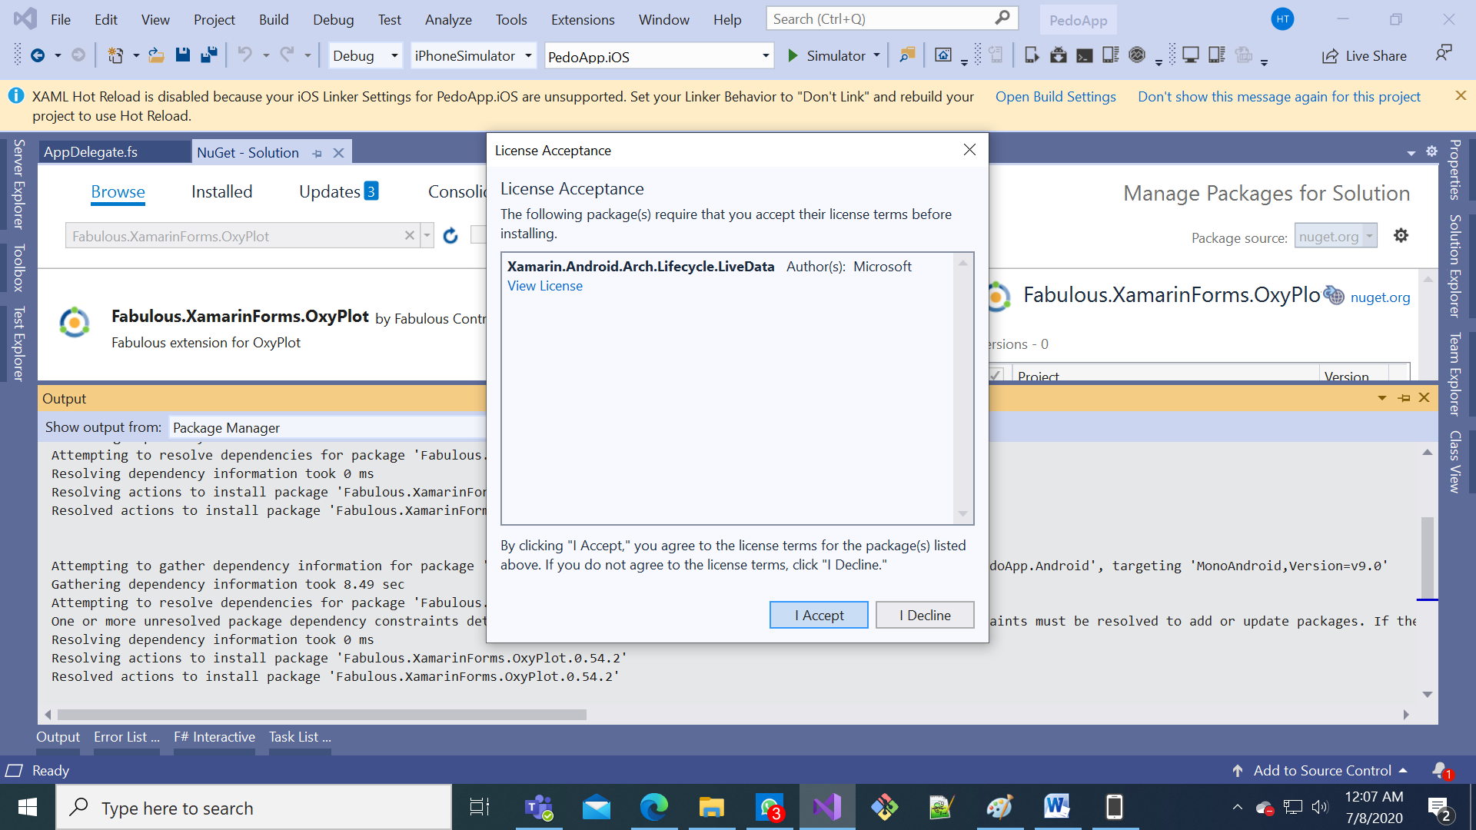
3. Close the “Manage Packages for Solution” page 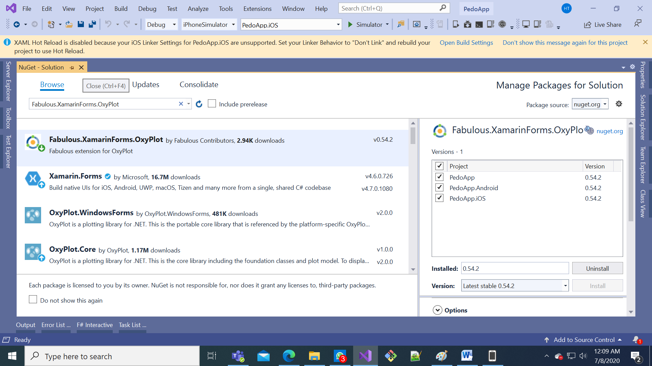
4. Remove red lines, add green lines in “PedoApp.fs”

...

open System.Diagnostics

open Fabulous

open Fabulous.XamarinForms

open Fabulous.XamarinForms.LiveUpdate

open Fabulous.XamarinForms.OxyPlot

open Xamarin.Forms

module App =

...

{ Count : int

Step : int

TimerOn: bool

Pedometer : int }

Pedometer : int list }

type Msg =

| Increment

...

| TimedTick

| PedometerUpdated of int

let initModel = { Count = 0; Step = 1; TimerOn=false; Pedometer = 0 }

let initModel = { Count = 0; Step = 1; TimerOn=false; Pedometer = [] }

let init () =

initModel, Cmd.ofSub (fun dispatch -> DependencyService.Get<Pedometer>().Step.Add(PedometerUpdated >> dispatch))

...

{ model with Count = model.Count + model.Step }, timerCmd

else

model, Cmd.none

| PedometerUpdated p -> { model with Pedometer = p }, Cmd.none

| PedometerUpdated p -> { model with Pedometer = model.Pedometer @ [p] }, Cmd.none

let view (model: Model) dispatch =

let plotModel = OxyPlot.PlotModel()

let line = OxyPlot.Series.LineSeries()

line.Points.AddRange(Seq.mapi (fun x y -> OxyPlot.DataPoint(float x, float y)) model.Pedometer)

plotModel.Series.Add line

View.ContentPage(

content = View.StackLayout(padding = Thickness 20.0, verticalOptions = LayoutOptions.Center,

children = [

...

View.Slider(minimumMaximum = (0.0, 10.0), value = double model.Step, valueChanged = (fun args -> dispatch (SetStep (int (args.NewValue + 0.5)))), horizontalOptions = LayoutOptions.FillAndExpand)

View.Label(text = sprintf "Step size: %d" model.Step, horizontalOptions = LayoutOptions.Center)

View.Button(text = "Reset", horizontalOptions = LayoutOptions.Center, command = (fun () -> dispatch Reset), commandCanExecute = (model <> initModel))

View.Label(text = sprintf "Pedometer: %d" model.Pedometer)

View.Label(text = sprintf "Pedometer: %A" model.Pedometer)

View.PlotView(model = plotModel, controller = OxyPlot.PlotController(), width = 400., height = 300., backgroundColor = Color.AliceBlue)

]))

// Note, this declaration is needed if you enable LiveUpdate

1. Remove red lines, add green lines in “MainActivity.fs”

...

Xamarin.Forms.Forms.Init (this, bundle)

Xamarin.Forms.DependencyService.Register<PedometerAndroid>()

OxyPlot.Xamarin.Forms.Platform.Android.PlotViewRenderer.Init()

let appcore = new PedoApp.App()

this.LoadApplication (appcore)

1. Remove red lines, add green lines in “AppDelegate.fs”

...

override this.FinishedLaunching (app, options) =

Forms.Init()

OxyPlot.Xamarin.Forms.Platform.iOS.PlotViewRenderer.Init()

let appcore = new PedoApp.App()

this.LoadApplication (appcore)

base.FinishedLaunching(app, options)

1. Debug to your device with the green arrow

|  |  |
| --- | --- |
| Initial look | After walking for a while (10+ minutes) |
| C:\Users\hadri\AppData\Local\Microsoft\Windows\INetCache\Content.Word\WhatsApp Image 2020-07-08 at 00.11.25.jpeg |  |